Lecture Notes: PowerPoint, Basic Skills

What’s PowerPoint?
PowerPoint is a full-featured presentations application that allows you to produce visually appealing presentations to show to your audience.
PowerPoint contains many features to plan, develop, and organize slides, including:
- providing design ideas,
- formatting text,
- adding and editing video and audio clips,
- creating tables and charts,
- applying artistic effects to pictures,
- animating graphics, and
- collaborating with friends and colleagues.
The beauty of PowerPoint: this YouTube video shows how to add a transition called “Morph” between the presentation’s slides to create a smooth movement from one slide to the next: https://www.youtube.com/watch?v=nPH1CNsEjvU.

Basic PowerPoint Terminology
Presentation and Slides are common ways to call a PowerPoint file.
Each presentation file is built up of slides (just like pages build up a Word document.)
A Deck is the set of all slides of a presentation file (like a deck of cards, but with slides.)

Using PowerPoint

Launching PowerPoint on Your Computer
Just as with the Word application, you can open PowerPoint by using your computer’s Search Bar to type ‘PowerPoint’, and then clicking on the icon of the application, which may be one of:
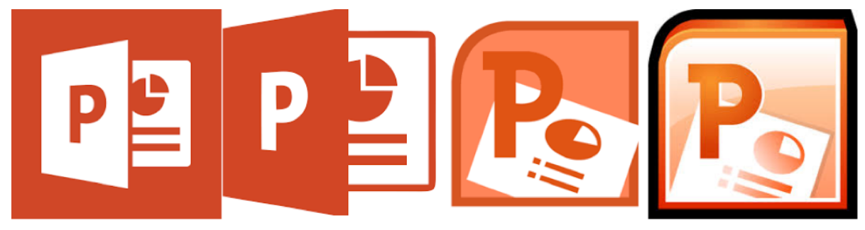
or by finding and clicking this icon elsewhere (in the Start menu, in the Applications folder, or the on Desktop.)

Creating a New Presentation
Once the PowerPoint app opens, it will look like:
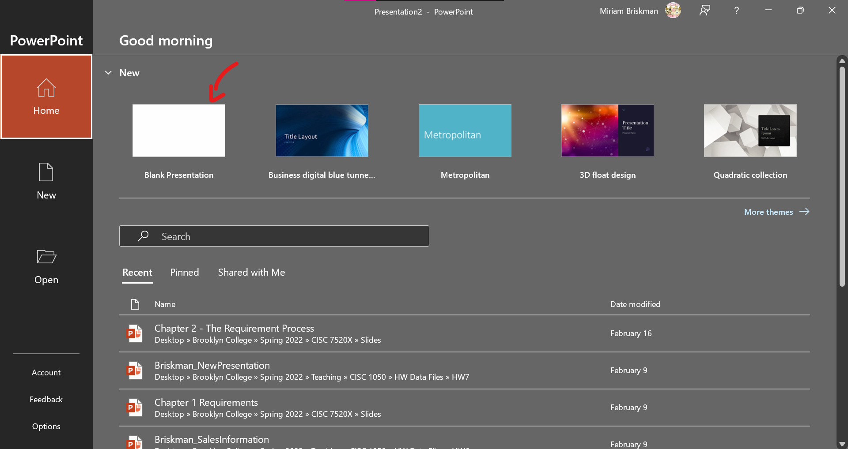
This isn’t just a déjà vu: the PowerPoint interface is strikingly like this of Word. In general, the Office applications we cover this semester will have similarly looking interfaces.
Now, click or double-click the Blank Presentation option to create a new, empty PowerPoint presentation. This presentation will consist of a single slide:
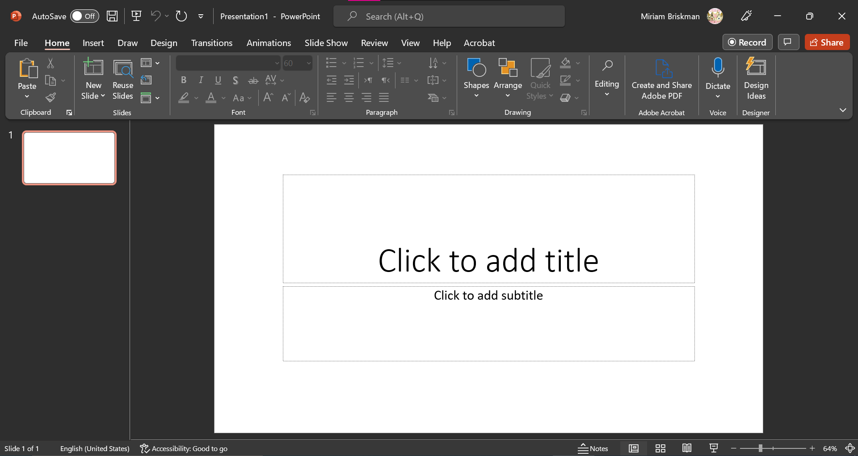

Overview of PowerPoint Controls
The window of the PowerPoint application is very similar to this of Word. Because we already spoke about the various areas on the Word window, here we just list the very few differences between a PowerPoint and a Word window:
- The Status Bar has the following commands:
  - Slide counter (“Slide x of y”)
  - Presentation language (E.g., “English (United States)”)
  - Notes button (to show or hide presenter’s notes) 
  - 4 view / layout options, which we’ll cover in more detail later:
    - Normal
    - Slide Sorter
    - Reading View
    - Slide Show
  - Zoom bar & plus/minus buttons
  - “Fit slide to current window” button
- PowerPoint has 3 tabs that Word doesn’t have: Transitions, Animations, and Slide Show.
- PowerPoint doesn’t have the References tab that Word has.
- PowerPoint has a Quick Access Toolbar button that Word doesn’t have: Start From Beginning button, which starts a slide show from the 1st slide .
- On the Home tab, you’ll find the following new buttons:
  - Slide-related buttons, like New Slide 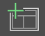, Reuse Slides  that lets you add slides from a different presentation file into the current file, and Slide Layout which lets you change the layout of the current slide. All are in the Slides group.
  - The Text Shadow button  that adds a shadow behind text, and the Character Spacing button  that adjusts the spacing between letters in the text. You can find these in the Font group.
  - In the Paragraph group, you will notice the Columns button , the Text Direction button , the Align Text button  (which places text at the top, middle, or bottom of a box,) and the Covert to SmartArt Graphic button which changes given text, text box, or other object into a SmartArt graphic (we will learn about SmartArt graphics later.)
  - You may also find the Drawing group on the Home tab. It allows you to add new shapes into the presentation, change their style, arrange shapes on the presentation, and change their background color, border color, and 3-D shape effects.
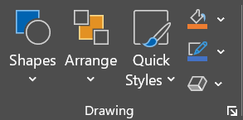

Themes
A Theme (or Template) is a pre-defined design with coordinated colors, fonts, and graphical effects that can be applied to presentations to give them a consistent, professional look.

Changing to a New Theme
To select a theme:
- Click on the Design tab.
- Look at the Themes group or click the More button to see all the available themes.
- Click OR double-click on the theme to select it.
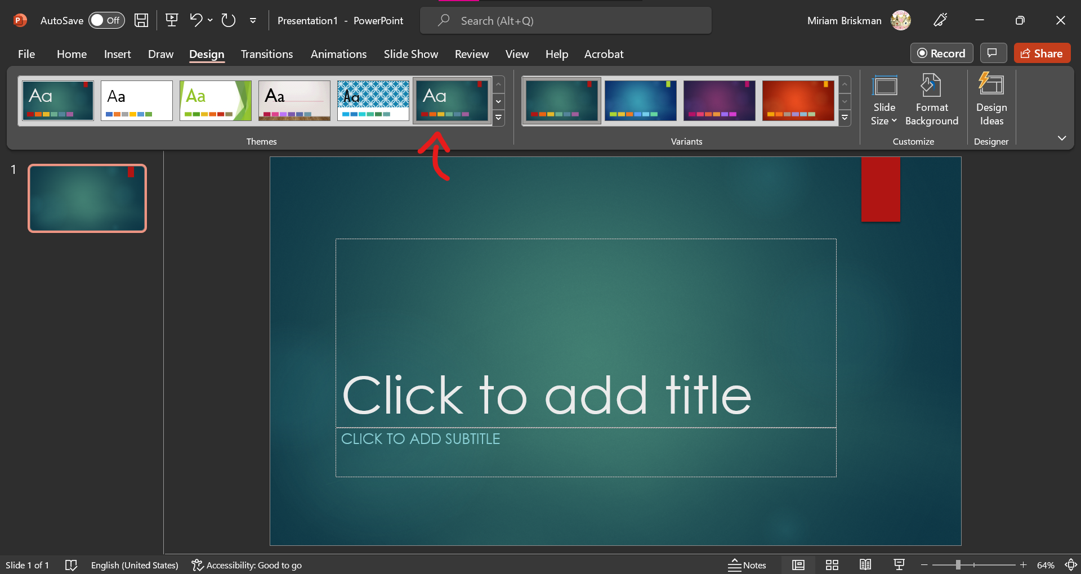
You can also change theme colors and style via the buttons in the Variants group:
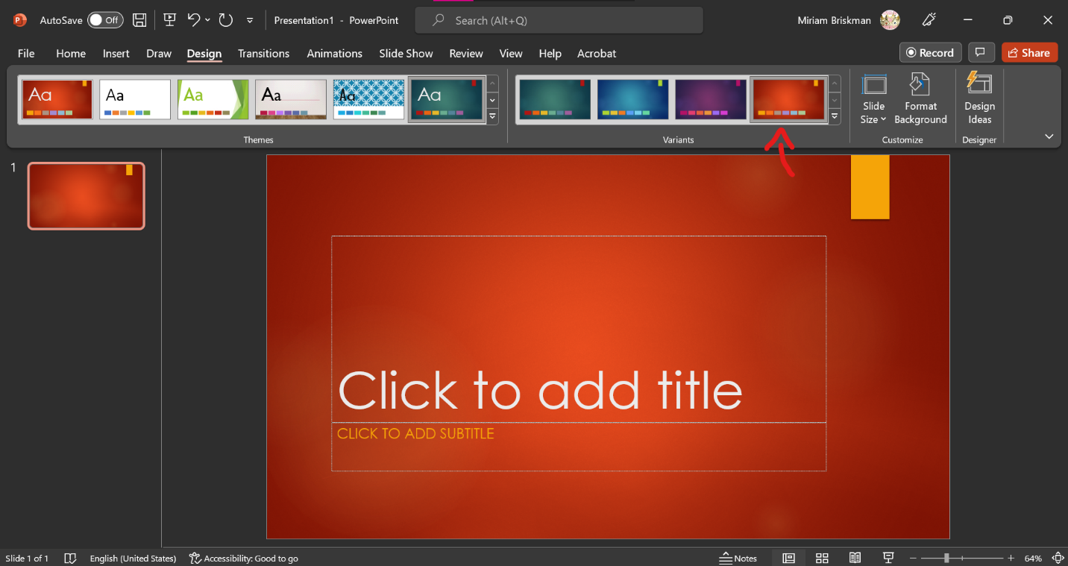

Using PowerPoint

Opening an Existing Presentation
To open an existing presentation, do either of the following:
- Double-click on the presentation file inside File Explorer/Finder/the Desktop.
- Right-click on the file and select “Open” or “Open with…” > PowerPoint.
- If PowerPoint is open, click the Ctrl + O keys to open the Open menu of PowerPoint.
- If PowerPoint is open, click File > Open to open the Open menu of PowerPoint.

Areas of the PowerPoint app Window
PowerPoint has several important window areas:
- Slide / Main / Active window: shows the slide on which we are currently working. This area is usually located at the very middle of the screen and occupies most of it.
- Slide Thumbnails / Slides Pane / Slides Area: shows all the slides in the presentation as miniature images, followed by one another from top to bottom. This area is running along the side of the screen, usually on the left.
  - The Active slide is highlighted in the Slides Area so that you immediately notice which slide has focus.
  - To make a slide the active slide, click on its image in the Slide Thumbnails area.
- Notes Area / Notes Pane: a short area in which you can add notes to your slides. It is usually located below the main window.
  - If you can’t see the Notes area, click on the Notes button on the Status Bar for this area to show up.
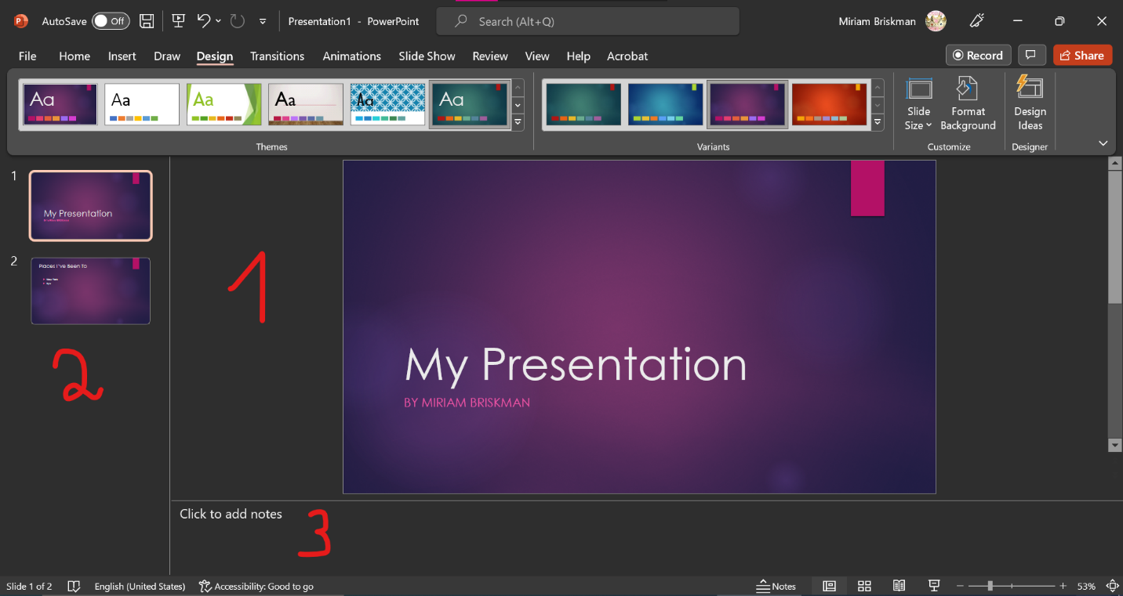

Editing a Slide
Some PowerPoint slides contain Placeholders, which are boxes with borders in which you can enter text.
Example of a placeholder:
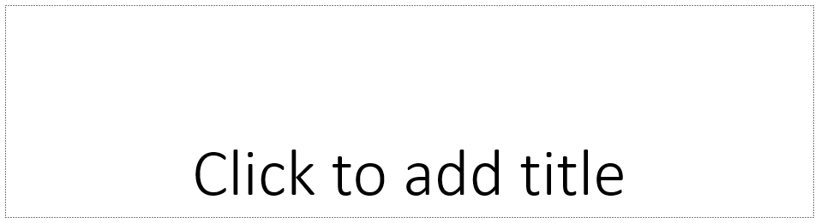
By default, when you are creating a new PowerPoint presentation, it will contain exactly 1 slide. This slide is called the Title Slide because it contains 2 placeholders: for a title and for a subtitle:
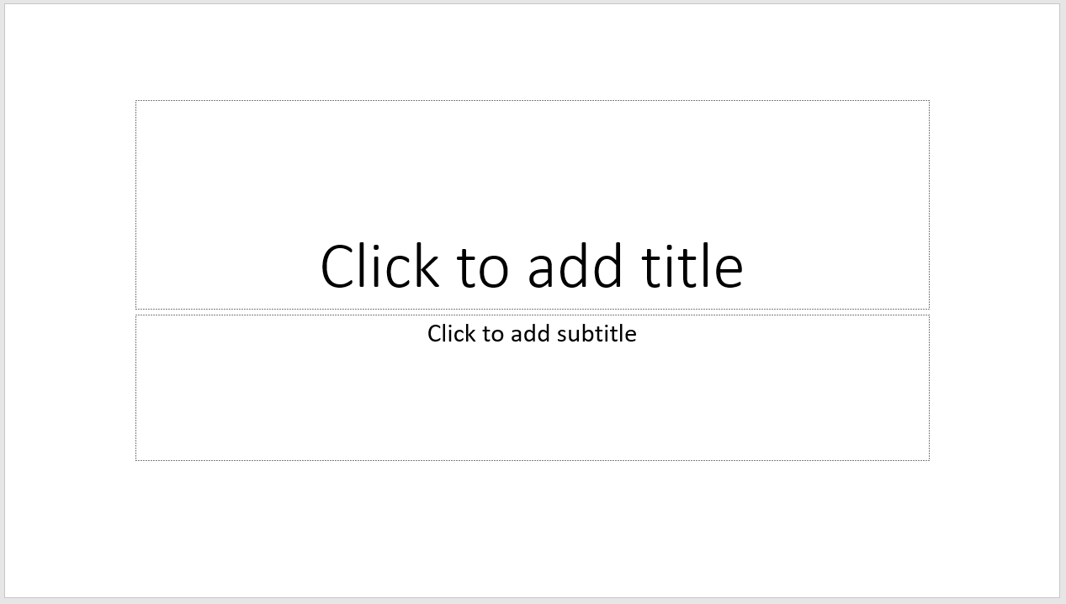
To add text into a placeholder (and to replace the dummy text,) click inside the placeholder and start typing:
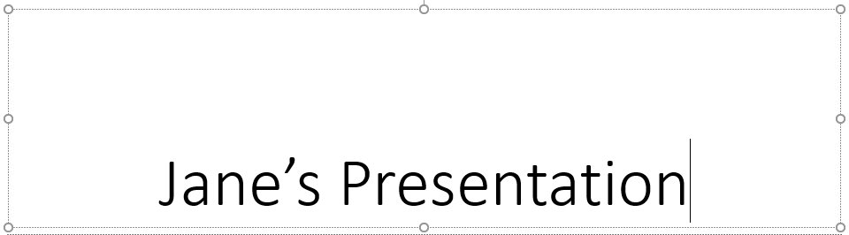

Adding Slides
You can, of course, add additional slides to your presentation.
To add a new slide, do one of the following:
- Home OR Insert tab New Slide button
- Home OR Insert tab New Slide arrow Click on the slide of the layout you want to add
  - There are 9 default slide layouts from which you can choose, one of which is the simple Blank slide layout.
- Right click a slide in the Slide Thumbnails area and choose New Slide.
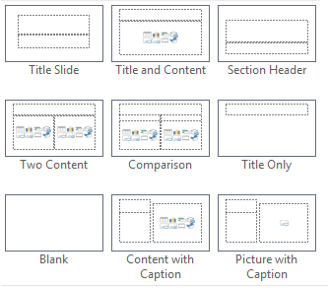

Changing a Slide’s Layout
You can change the slide’s layout at any time, so no worries if you added a slide you didn’t want by mistake, or if you change your mind while editing the slide.
To change a slide’s layout, click on the Layout button on the Home tab Slides group, and choose the new layout you want to add:
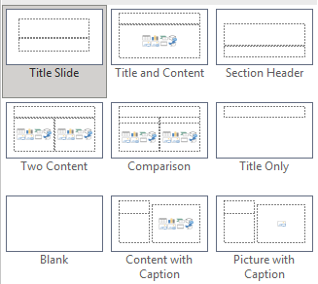

Deleting a Slide
To delete a slide that you don’t need/want, do one of the following:
- Click the slide once Press the DELETE or BACKSPACE keys on the keyboard.
- Right-click the slide Click the Delete Slide option.

Reordering / Moving Slides
You can change the order of the slides (e.g., put slide 3 before slide 2) by clicking, holding, and dragging one of the slide thumbnails to a new place before or after another thumbnail within the Slides Pane:
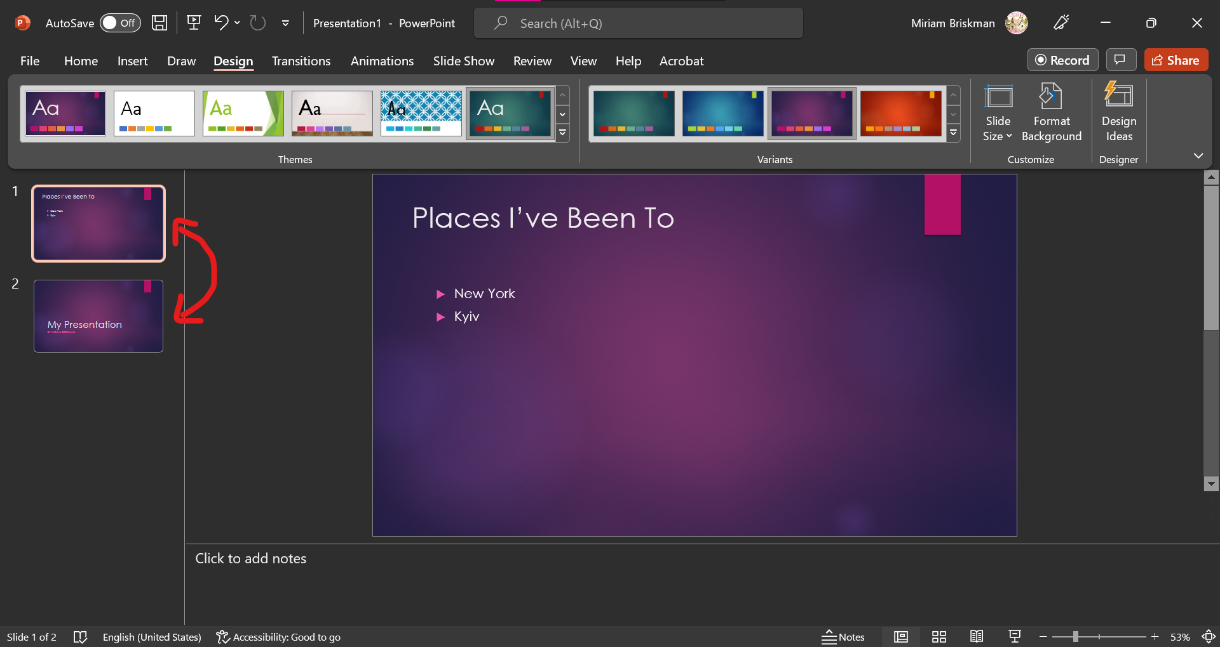

Presentation View Ways
There are several ways to view your presentation (see examples in screenshots next page:)
- Normal View: The default way you see a PowerPoint presentation when you create a new one: the Main slide window is at the screen’s middle, while the slide thumbnails are on the left side. All the screenshots above are in Normal View.
- Outline View: The same as above, except that, instead of thumbnails, you see the text that each slide contains on the slide pane.
  - You can edit the text from there by double clicking it and typing!
- Slide Sorter: At the middle of the screen, you will see enumerated medium-sized images of all the slides in your presentation (you may still need to scroll down to view all the slides.)
- Notes Page: You’ll see letter-sized pages, each of which has two parts: a medium-sizes image of a slide (at the top,) and the notes you added into the Notes Pane area (at the bottom.)
- Reading View: Very similar to seeing a Slide Show, but your computer’s taskbar and PowerPoint’s Status bar remains visible.
To change to one of the mentioned views, click the View tab Presentation Views group click the button pertain to the view to which you wish to switch.
Examples:

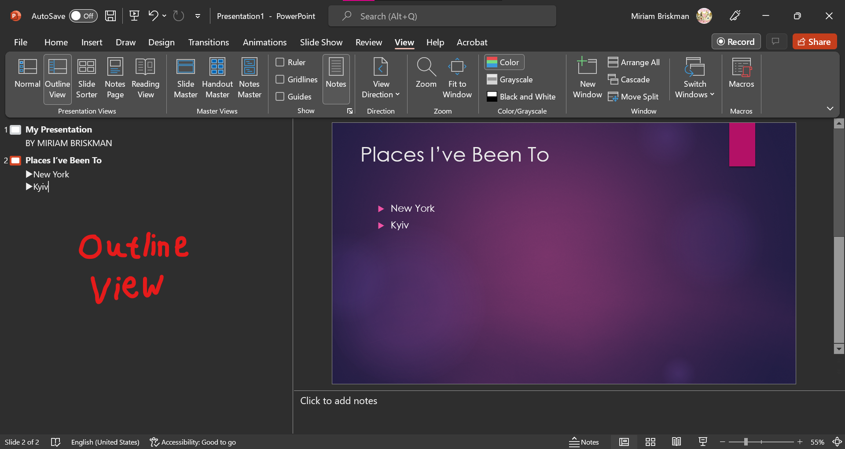

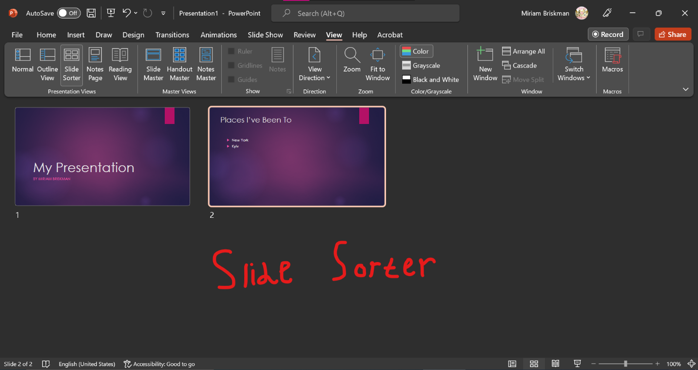

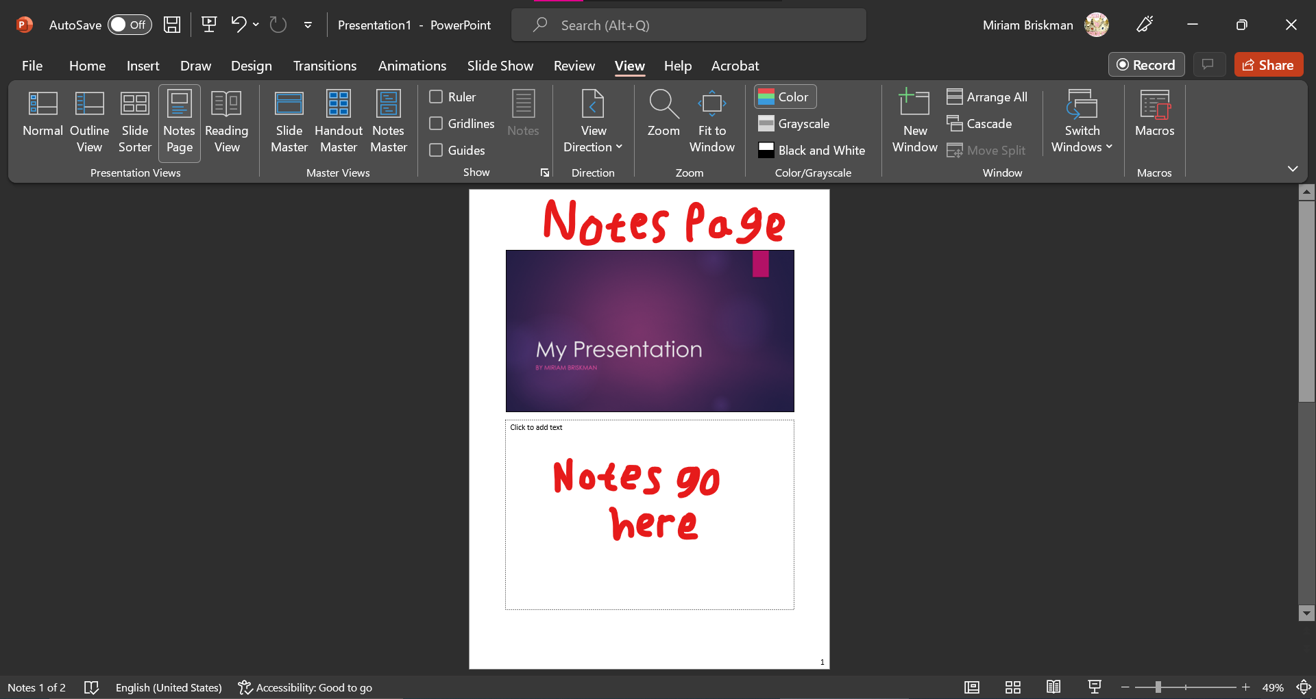

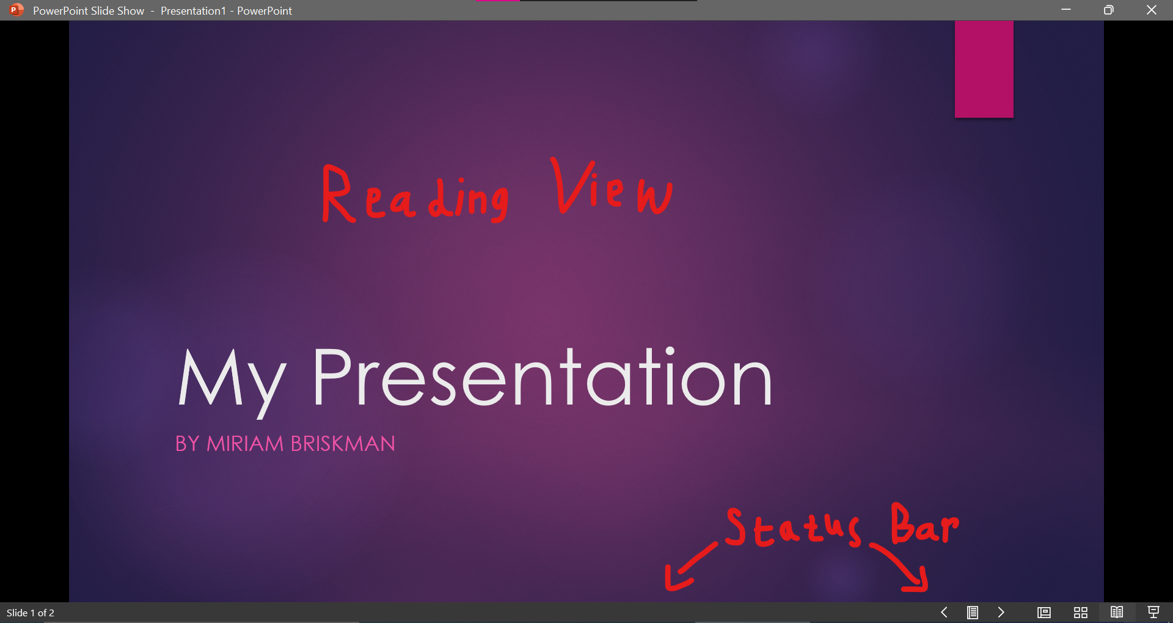

Objects in PowerPoint
You can insert object: text boxes, pictures, icons, smart art graphics, charts, etc., into PowerPoint in the same way as in other Office applications (e.g., Word!)
The methods of inserting text boxes and images are identical to this we saw for Word, so in the scope of this lecture, we discuss objects that we haven’t encountered in the Word app.

Inserting Objects using the Content Placeholder
Some layouts of the slides you add into the presentation, such as “Title and Content,” “Two Content,” or “Comparison”, will include a Content placeholder of the following structure:
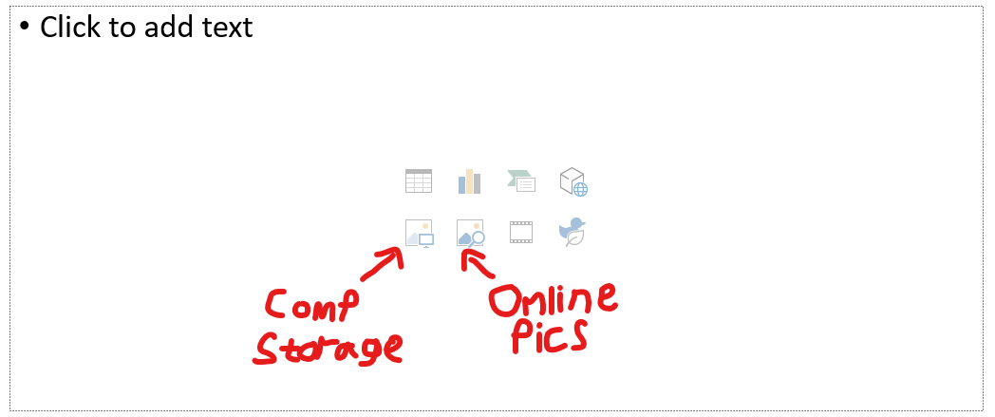
One way to use this placeholder is by clicking inside it and starting to type text.
However, another common usage is adding objects! Just click on one of the 8 small icons in the middle of the placeholder to add a specific object.
The objects you can add this way are (from top to bottom, left to right:)
- Table 
- Chart 
- SmartArt Graphic 
- Three-Dimensional (3D) Model 
- Picture (from your computer) 
- Picture (from online) 
- Video 
- Icon 
Of course, you can add each of these objects also via the Insert tab as you did in Word.

SmartArt Graphic
A SmartArt graphic is a customizable diagram that can visually represent lists, processes, and relationships. It comes in many types and shapes!
Most Office applications allow you to insert a SmartArt graphic, including Word and PowerPoint.
Examples of SmartArt Graphics in Word:

Insert a SmartArt Graphic
Word has a rich selection of SmartArt graphics for all kinds of purposes.
To insert a new graphic, click Insert tab Illustrations Group SmartArt button .
The popping dialog box will show all the existing SmartArt graphics you can choose from:
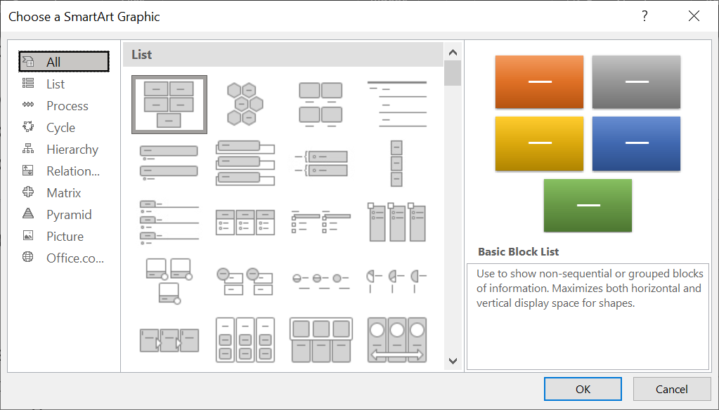
The “Alternating Hexagons” SmartArt graphic inside a PowerPoint slide look like:
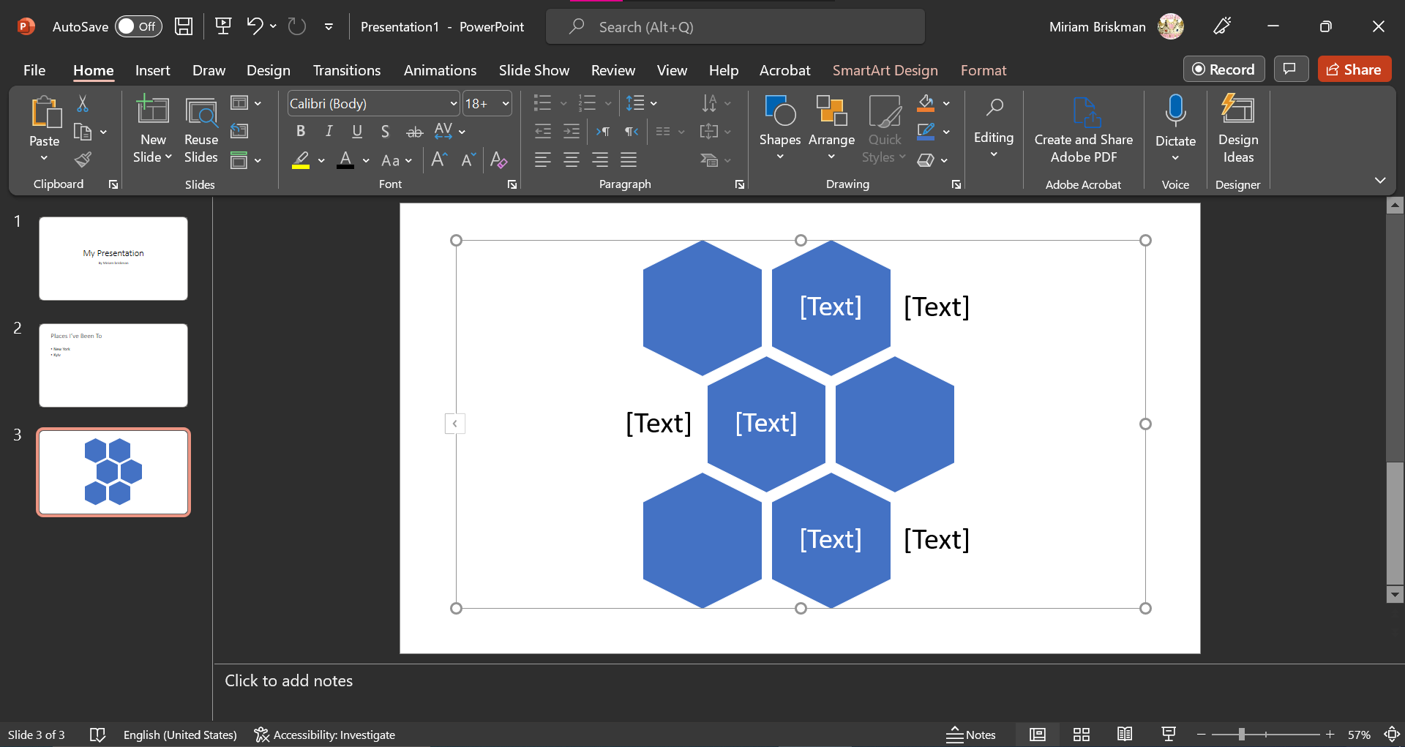

Typing Text
Click inside the [Text] placeholders to replace them with your text:
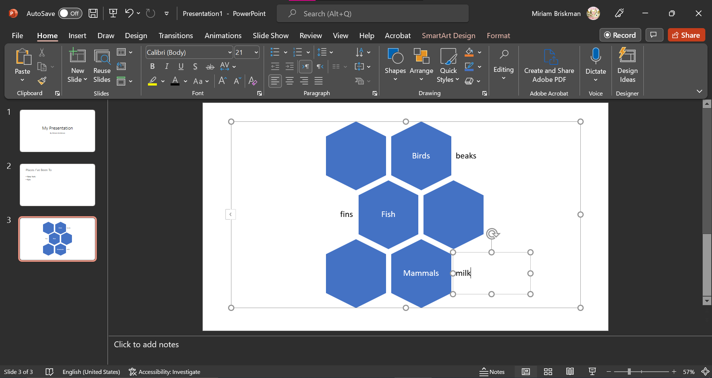
As you type, the font-size of the typed text will adjust based on the length of the text and the sizes of the shapes of the graphic.
Alternatively, click on the “SmartArt Design” tab Text Pane button  to access and type text inside the pane:
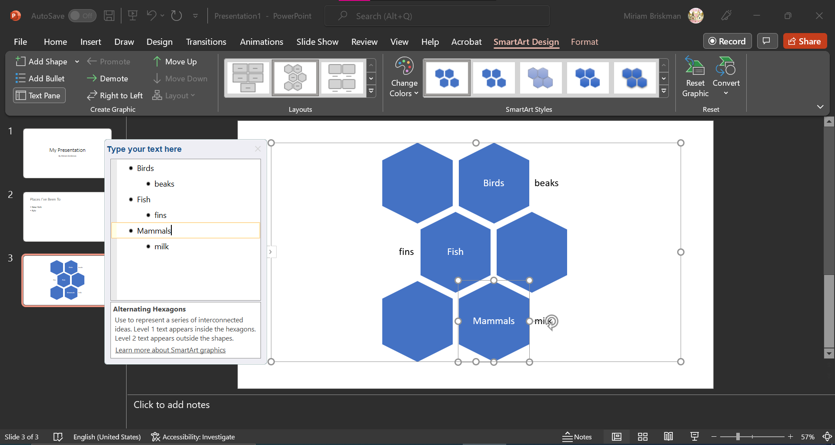

Changing Style
Using the same SmartArt Design tab, you can change the style of the graphic within the SmartArt Styles group of buttons. Make sure to click on the outer boundary of the graphic first before applying any changes, so that these changes apply to the entire graphic:
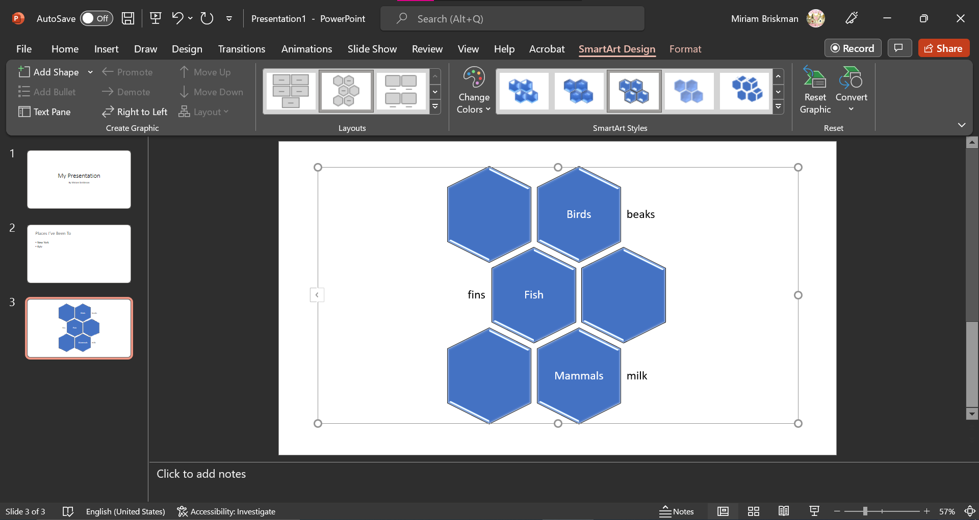
Moreover, you can change the colors of the shapes using the Change Colors button. 
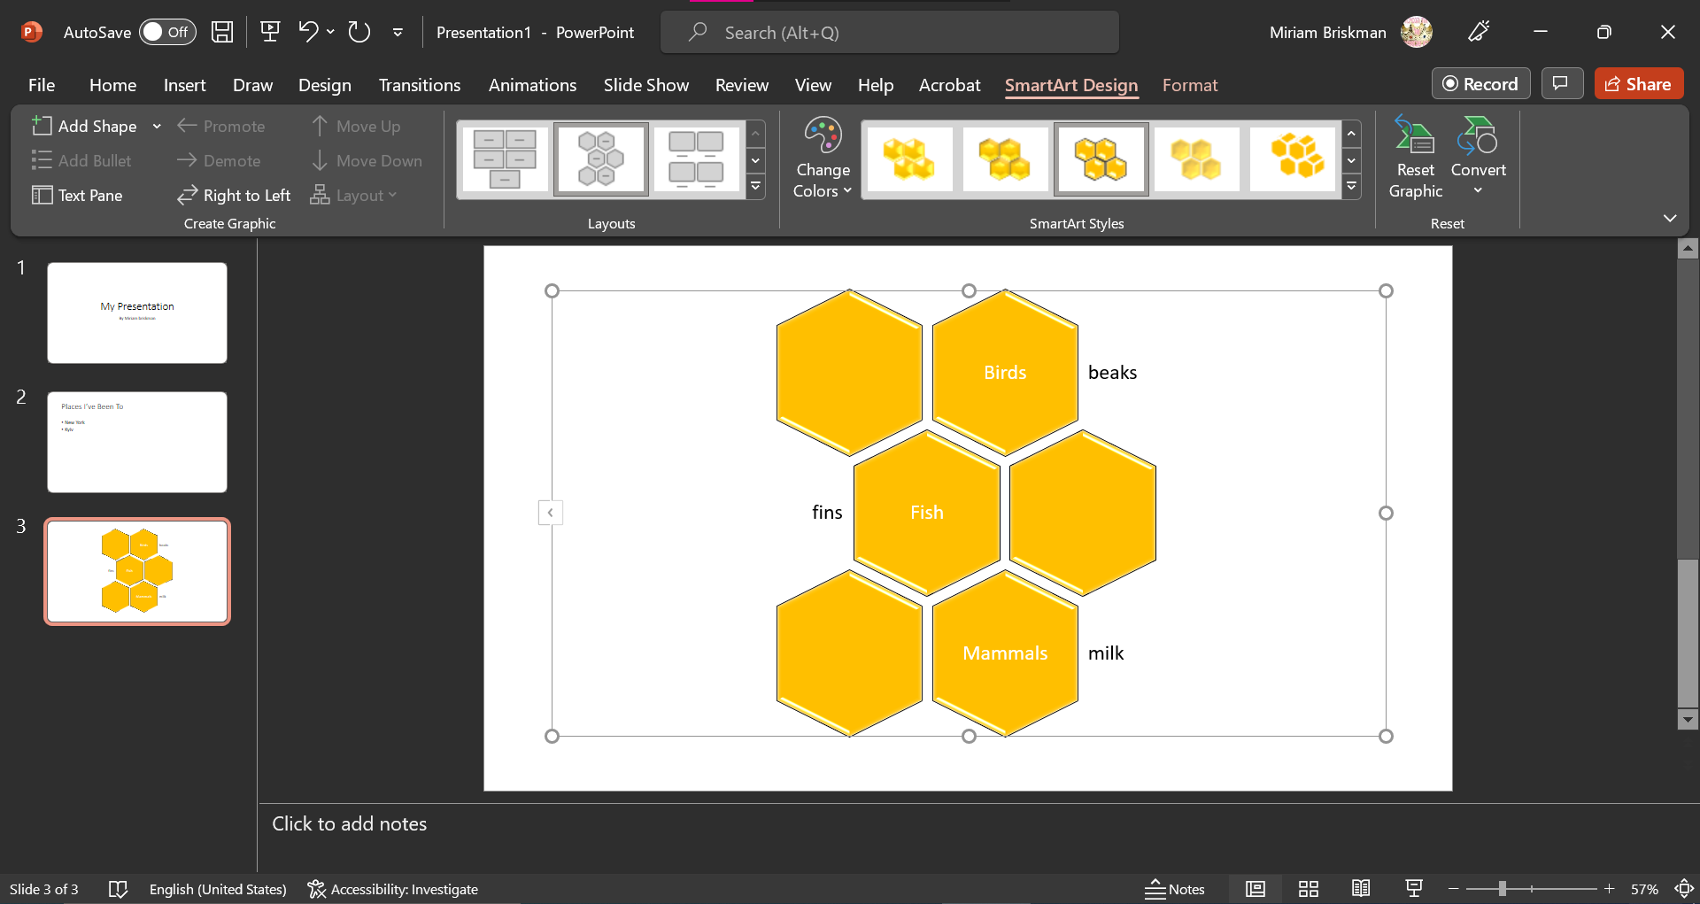

Changing Font Properties
Since text inside a SmartArt graphic behaves like any other text within the presentation, you can change the font properties of it using the Home tab. Below, we set the text to 28 points of size and to black font color:
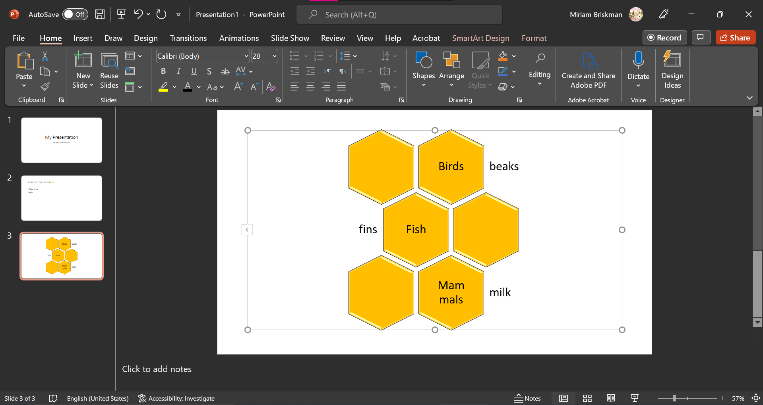

Adding More Shapes inside the Graphic
If you realize that additional shapes are needed within the graphic, click the SmartArt Design tab Add Shape button . This will add a shape to the end of the graphic (bottom or to the right.)
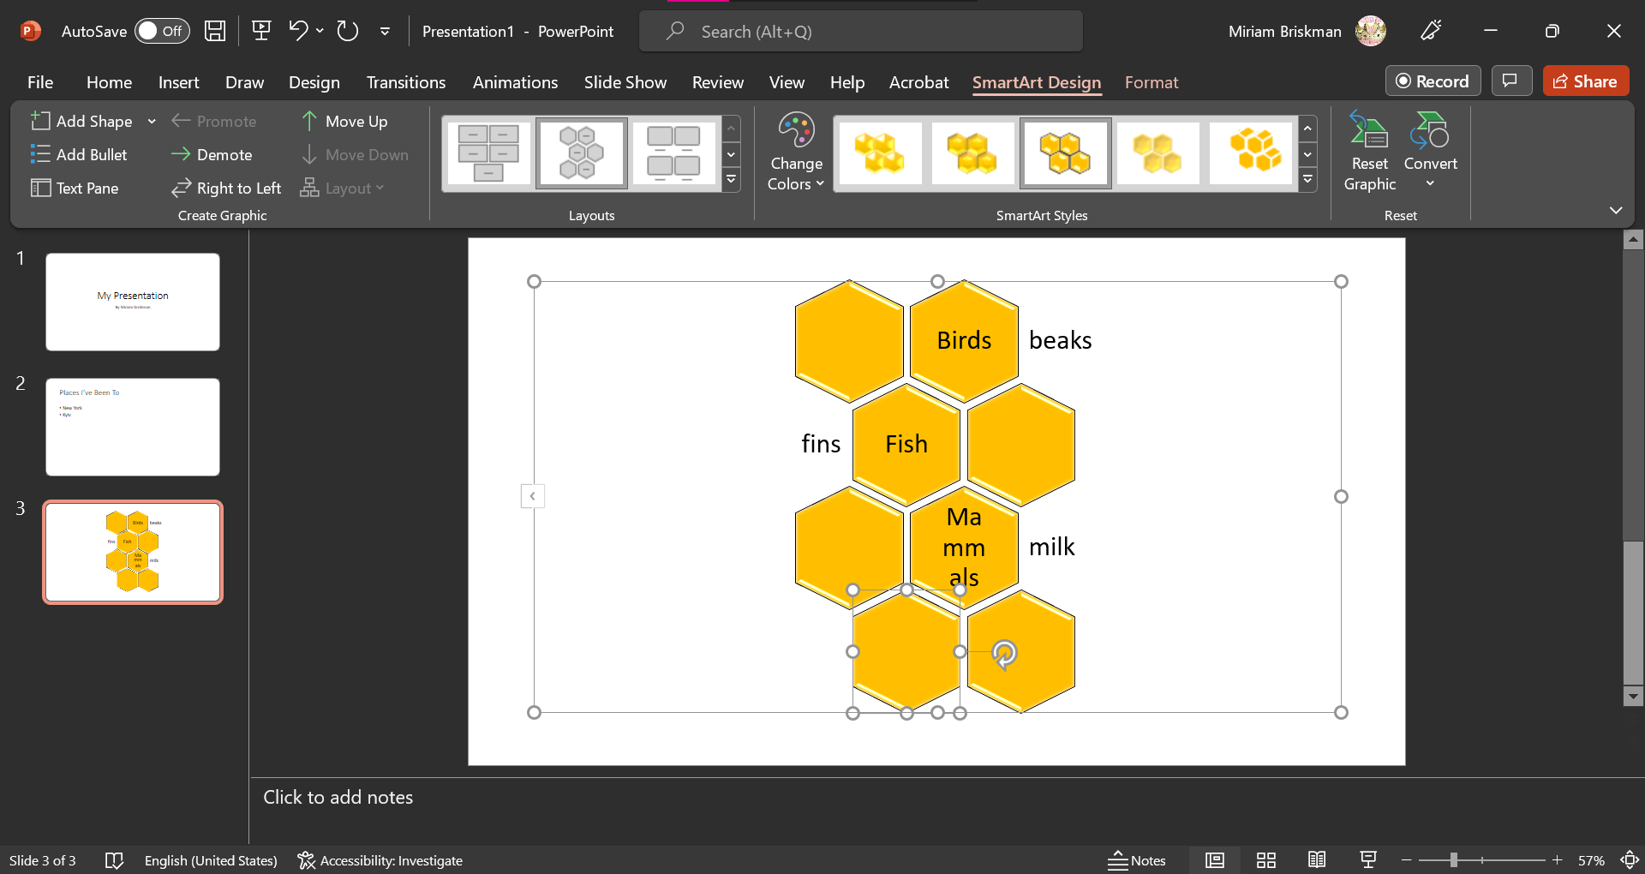
Alternatively, click on one of the middle shapes and then on the Add Shape button to add a shape right after it:
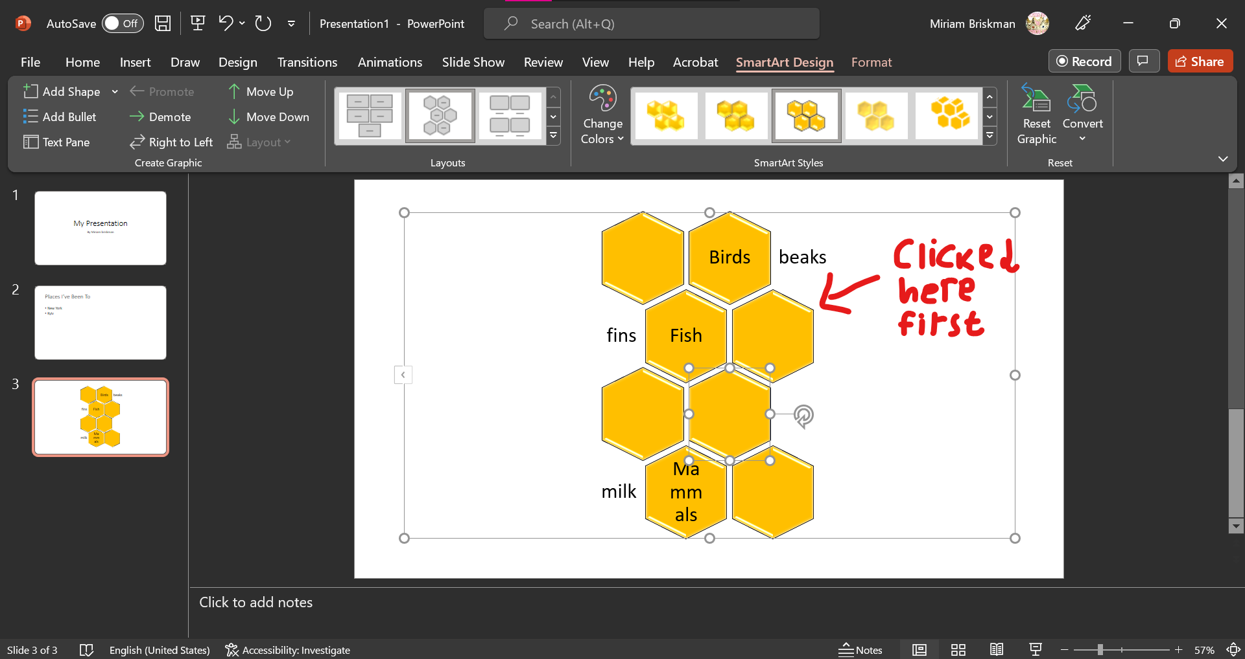
To add text into the new shape, click it and start typing, or use the Text Pane:
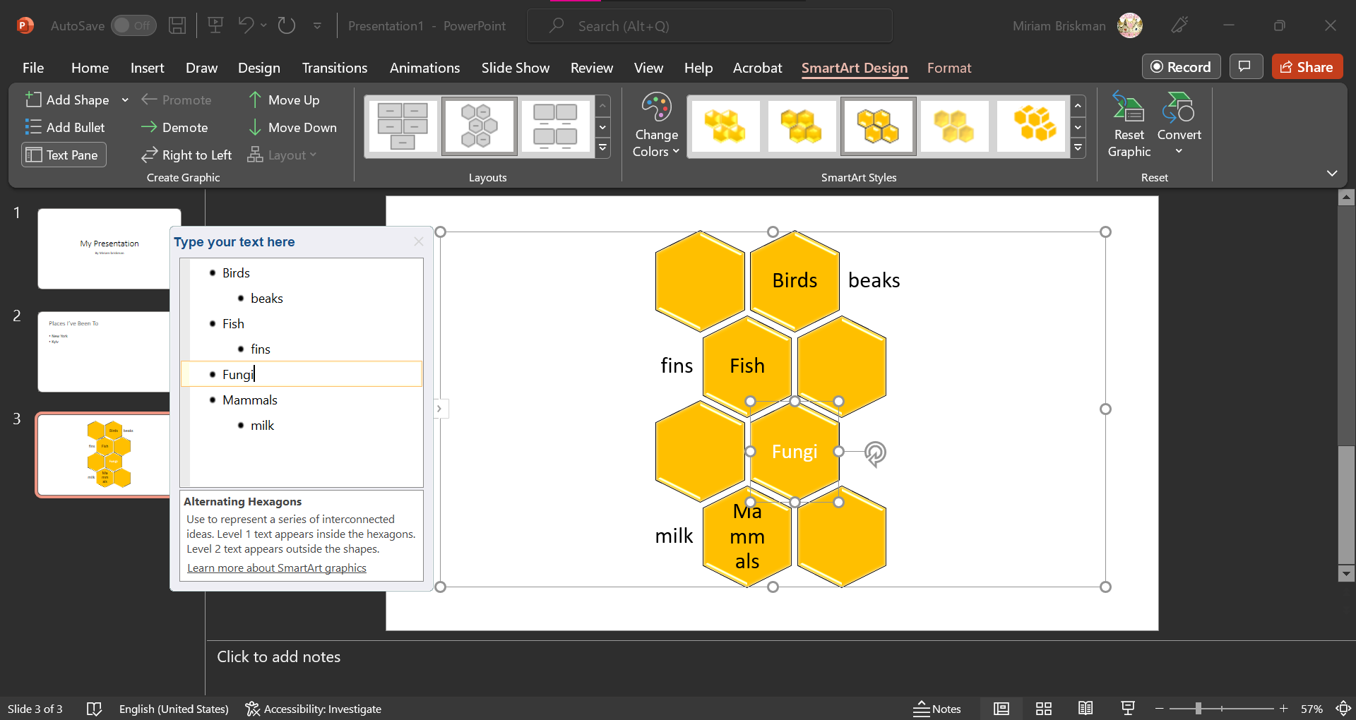

Deleting a Shape
If some shapes aren’t needed anymore, click on it, and click the DELETE or BACKSPACE key as many times as needed. Below, we delete the “Birds” shapes:
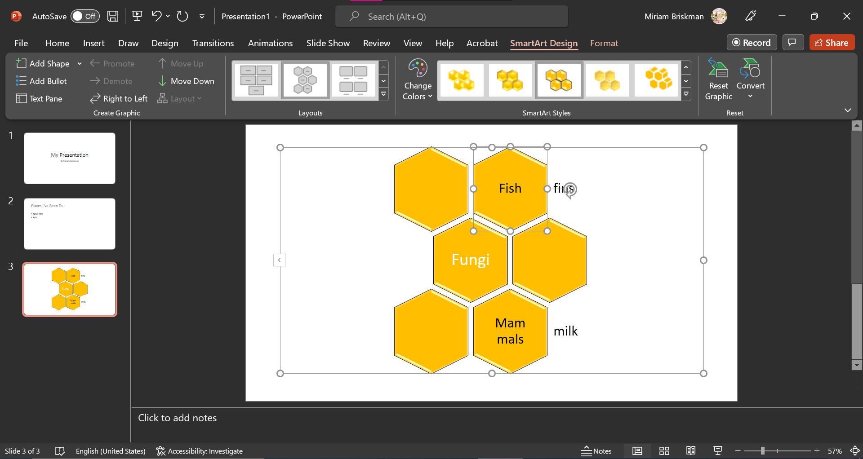

Convert a SmartArt Graphic to an Image
By clicking the SmartArt graphic SmartArt Design tab Convert button , you could change the SmartArt graphic into a shape, image, or simple text.

Arranging Objects (Shapes, Pictures, SmartArt graphics, etc.)
- You can design how to arrange (move around) the objects on a slide.
- Arranging can be done via the Home tab Drawing group Arrange button 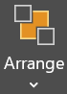:
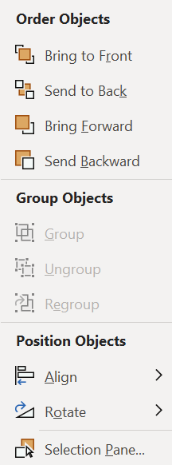
- For a single object, you can:

  - Decide whether the object will be displayed behind other objects or in front of them.

This is a very, very, very, very, very, very, very long line of text.

  - Decide at which place on the slide the object will be displayed (left, center, right, top, middle, bottom of slide.) [Through Align.]

  - Decide how you want the object to be rotated or flipped. [Through Rotate.]

- For two or more objects, you can also:
  - Decide whether you wish to group them. That is, merge these several objects into a single object (see Grouping Objects below.)
  - Decide whether you want to distribute them across the slide: You can set even spaces between every two objects and between an object and the margin. You can do so by Arrange Align Distribute Horizontally or Distribute Vertically.



Grouping Objects
- As we said, we can group two or more objects into 1 shape. To do so:
  - Select all the objects you wish to merge into one object by using the Ctrl key.
  - Click Home Arrange Group button.
Separate shapes vs. grouped shapes:
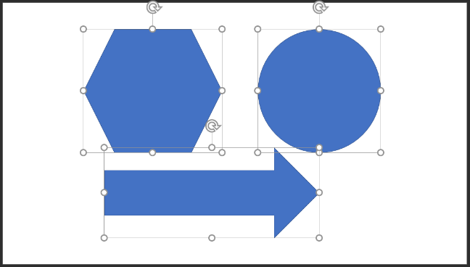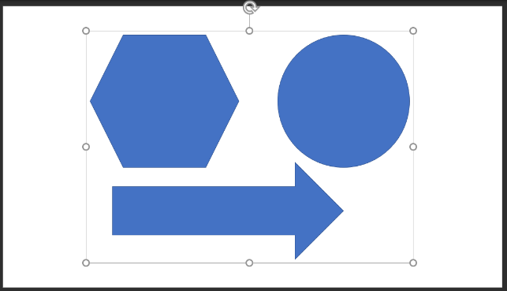
- Since each of the objects inside the merged object is a sub-shape, you can change the features of such inner shapes!
  - Double or triple-click an inner shape to change it (its size, font, etc.)
  - You can also freely move that inner shape.
  - In the example below, we move the circle down and to the left:
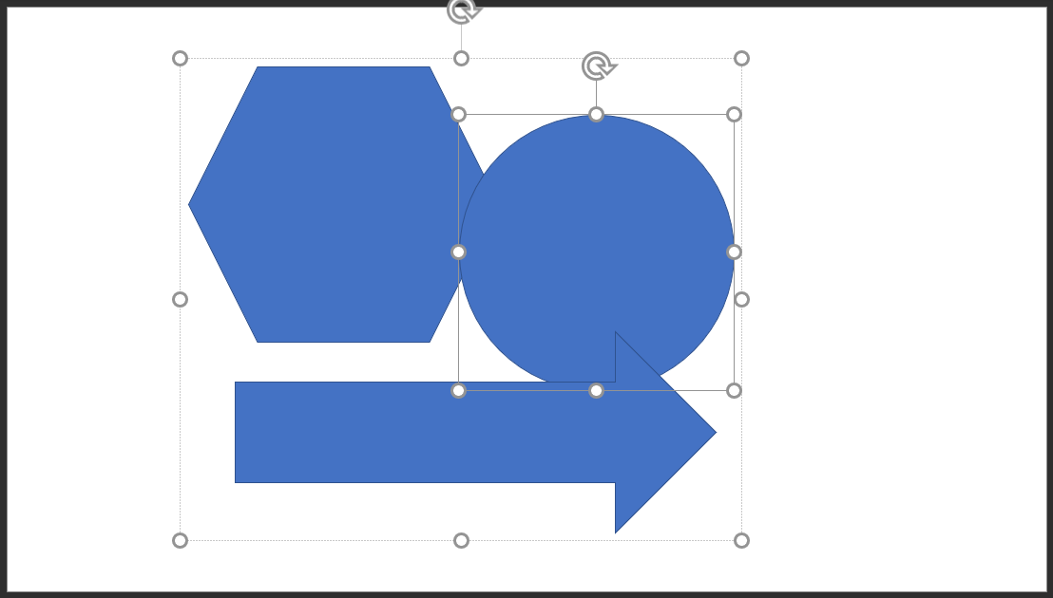
- If you think that a merged object should be broken down to its original components, you can simply ‘ungroup’ it.
  - Just select the object and click on Home Arrange Ungroup.

