Lecture Notes: PowerPoint, Intermediate Skills

Transitions
The slides that we have been working with so far are still: when viewing the presentation as a slide show, a slide will instantaneously change into the next one.
We can change this by adding some outstanding transitions between slides!

Adding a Transition
You can add at most one transition to each slide, including to the Title Slide.
To add a transition to the currently active slide (the one currently displayed at the middle of the PowerPoint window,) open the Transitions tab, and click on one of the transition options under the Transition to this Slide group:
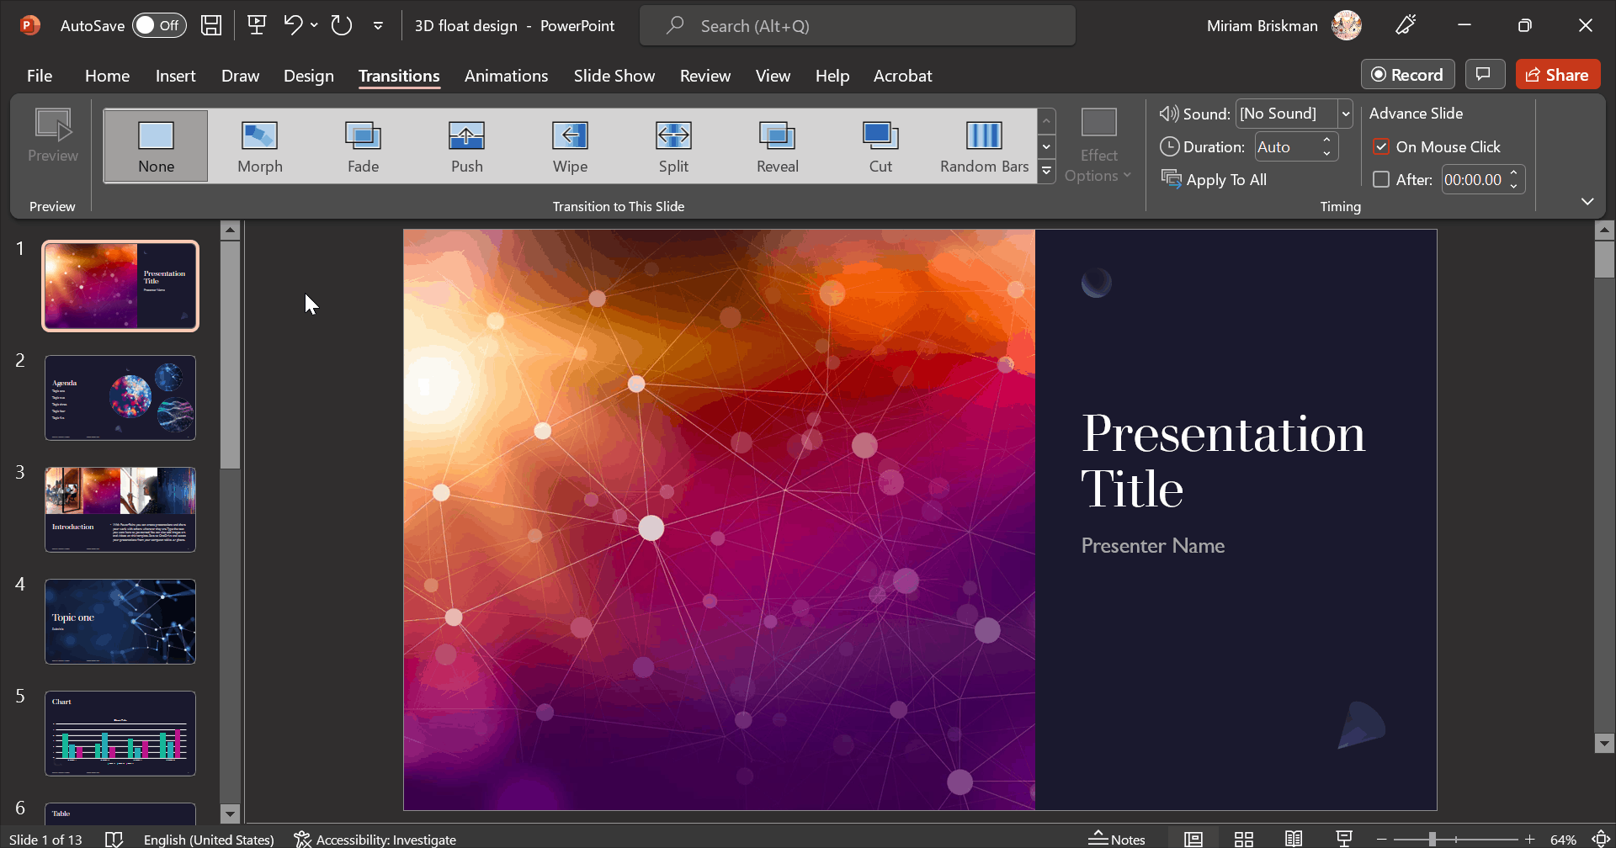
^ We added the “Split” transition to the above slide.
You can select among ~50 existing transition!

Other Transition Options
In addition to adding a transition, you can:
- Change the direction in which the transition manifests using the Effect Options button:
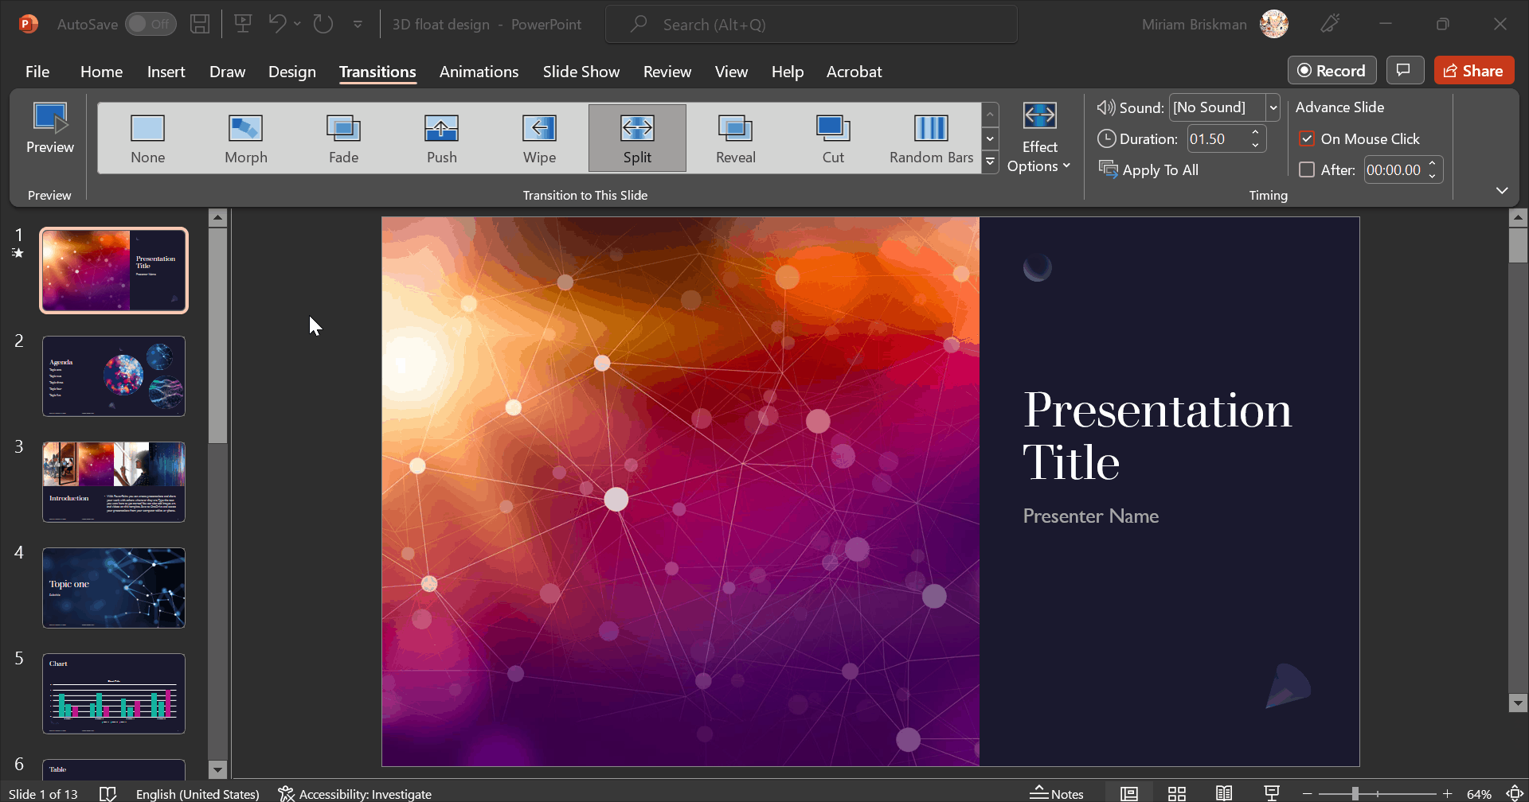
^ We tested all the 4 effect options of the Split transition.
- Change the Duration (length of time in seconds) it takes the transition to happen.
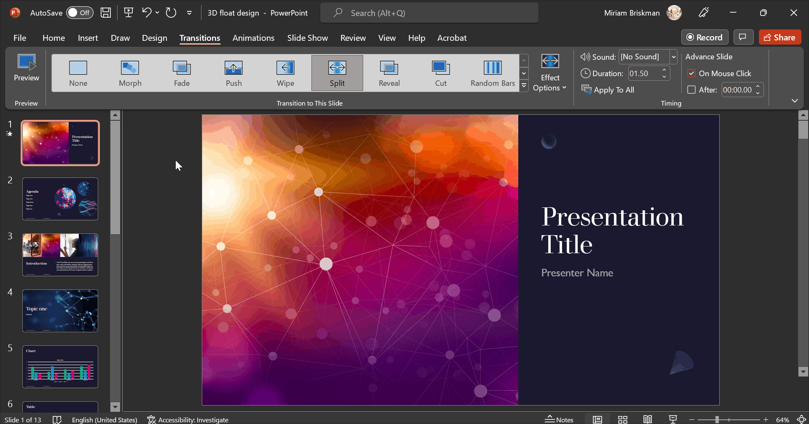
^ A change in the duration of the transition from 1.5 secs to 3 secs and then to 6 secs.
- Using the Advance Slide options, decide whether the transition occurs when you click the slide during the slide show, or after a certain number of seconds.

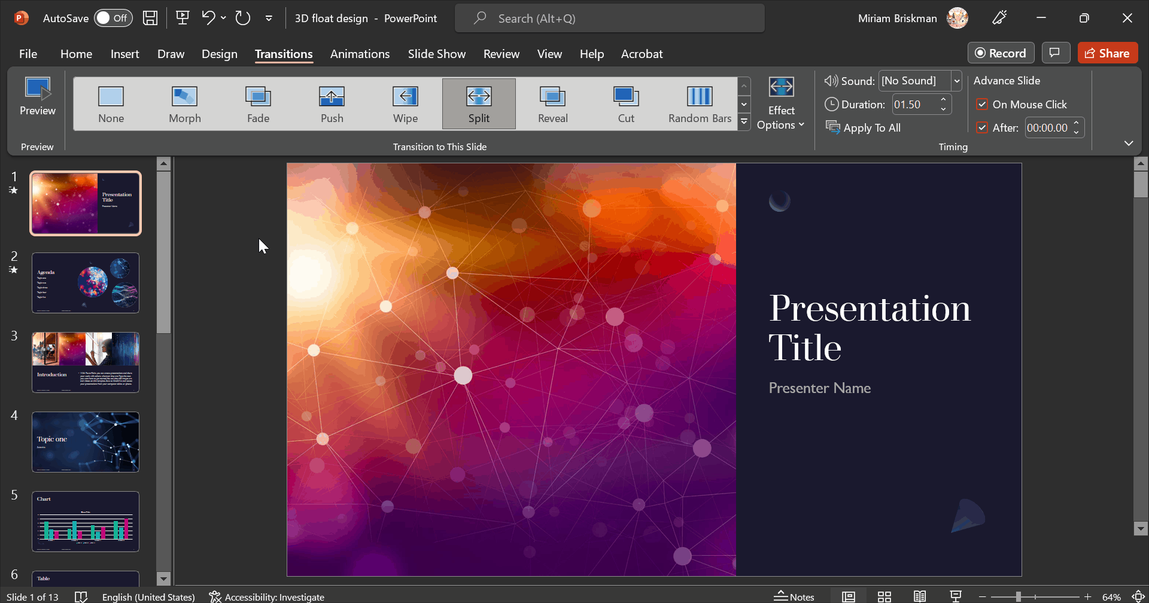
^ We added a transition (Random Bars) to the 2nd slide and made the 1st slide advance to the 2nd slide after exactly 5 seconds, without clicking.

Footer on a Slide
Just like with Word, you can access a slide’s footer and enter information into it.
The footer in PowerPoint can include:
- Date and time (either fixed or updated automatically)
- Number of the current slide
- Free-form footer text of your choice (e.g., the title of the presentation, the company’s name, etc.)

Adding a Footer
To add a footer that will repeat across all the slides, click the Insert tab Header & Footer button, and fill out the data you wish to appear on the footer.
The footer’s data will appear at the bottom of each slide.
See the image of the Header & Footer dialog box on the next page.
If you don’t want the footer to appear on the Title Slide, check the box next to Don’t show on title slide.

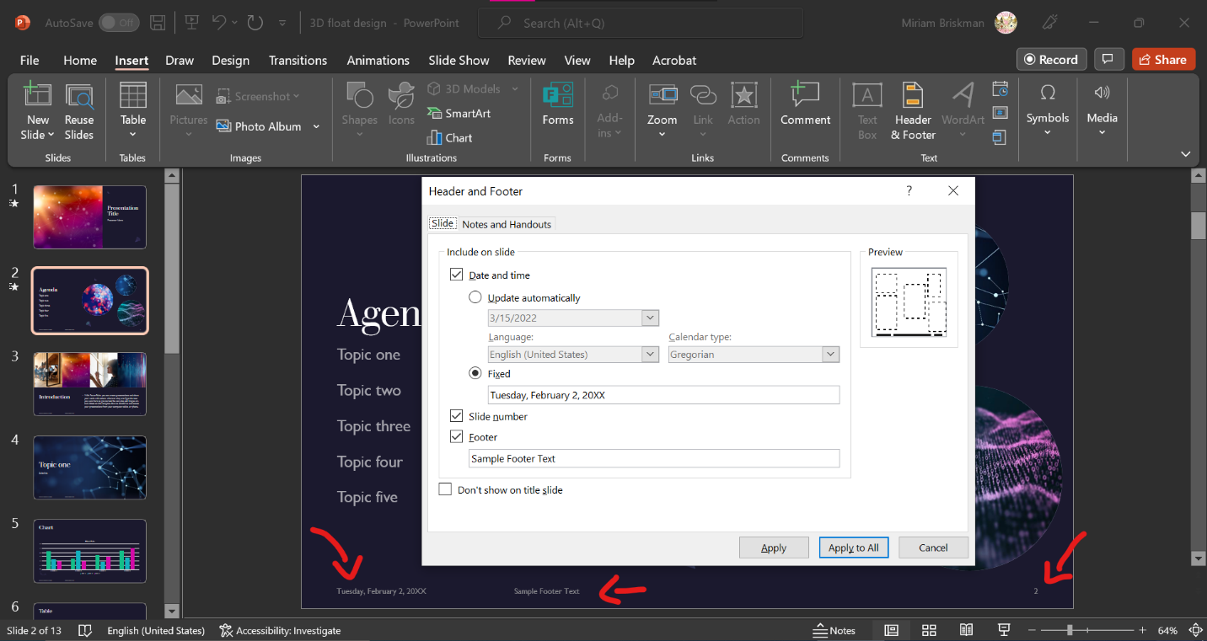

Slide Orientation
Every rectangular page has a feature called orientation, which tells on which side the slide is laying.
There are two orientation types: portrait and landscape.
Below, the shape on the left is in portrait orientation, while the one on the right has a landscape orientation.
Portrait!
Landscape!
In simple words, if the width of a slide is shorter than its height, the slide is portrait. Otherwise, if the width is longer than the height, the slide is landscape.
The default orientation of a PowerPoint slide is landscape, as the following screenshot shows:


Videos
You can upgrade you presentation even further by inserting a video clip that you can play directly within PowerPoint!
There are two ways to insert a video: (1) Linking an online video (2) Inserting a local video.
In any of these ways, the presenter could click ‘play’ within the presentation or the slide show to show the video to the audience.

Linking a Video
Using this method, you can insert a player of a video from an online source.
The advantage: the video doesn’t enlarge the size of the PowerPoint file because the video we only link it (but not copy it) into the presentation.
The disadvantage: the video won’t play when there’s no internet connection, and some Word versions don’t let linking an online video (an error message appears on the screen.)
To link an online video, click the Insert tab Media group Video Online Videos… or Stock Videos… (if the latter option is available.) Afterwards, paste the address of the online video, and click the Insert button to insert the video.
See illustrations on the next page.
Alternatively, on some computers, the Insert Video button inside the Content Placeholder will let you choose to insert a video from Online. If it does not let adding an online video, it will let you insert a video from your computer, as we shall see next.
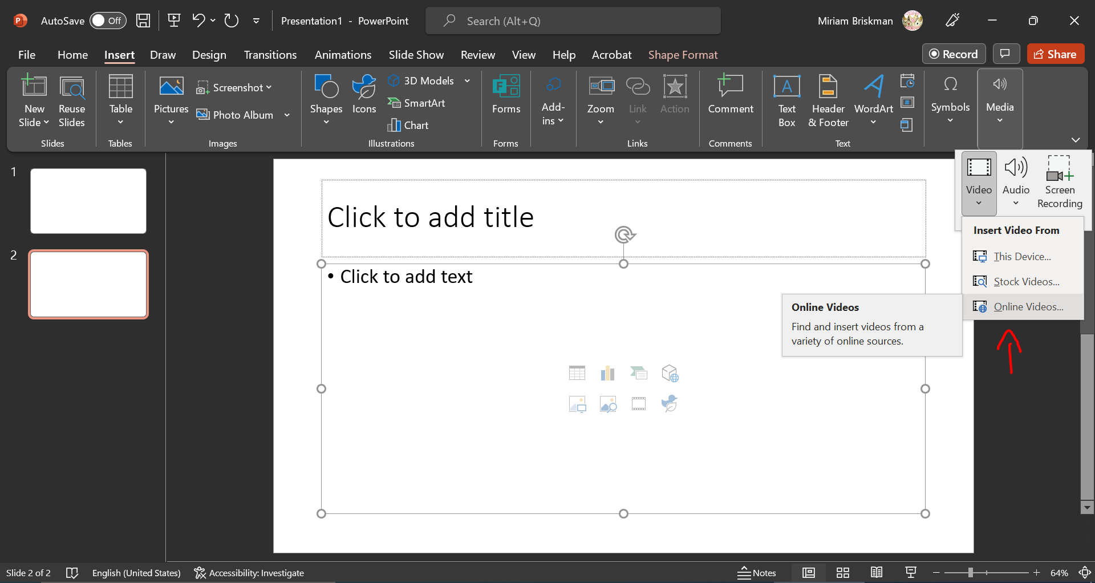
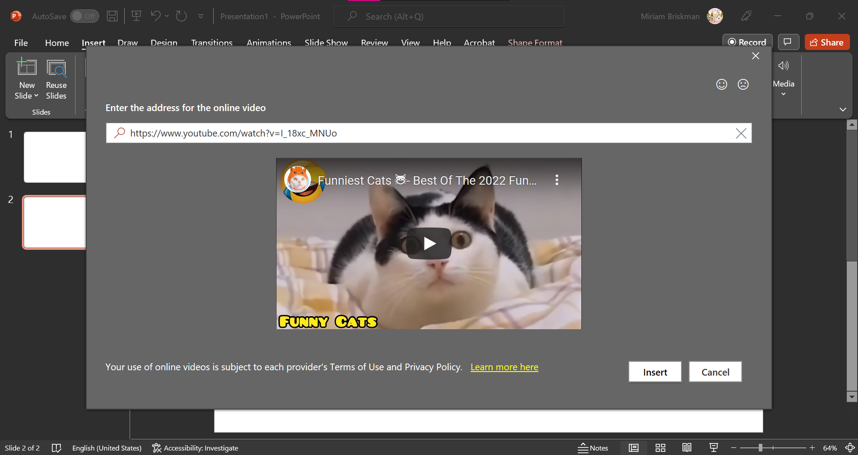
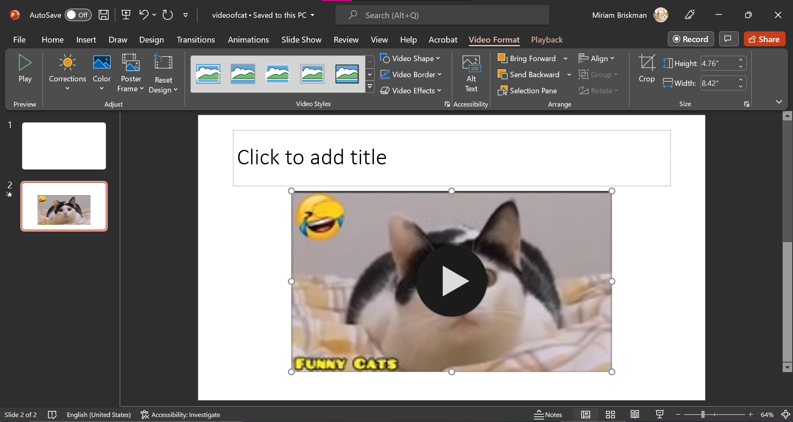

Inserting a local video
Because not all computers let linking a video, we can insert a local video instead. This will copy the content of a video into the presentation rather than just insert a link to it.
The advantage: the video will be available within the presentation even without internet connection, and Word versions support this option.
The disadvantage: the presentation might become very heavy because we copy the entire video into it: videos can be exceptionally large. This could cause the presentation to take a long time to load and to work.
To insert a video, click the Insert tab Media group Video This Device…. Afterwards, find the video on your computer, and click the Insert button to add the video.
You may also click the Insert Video button inside the Content Placeholder to add a video from your computer.
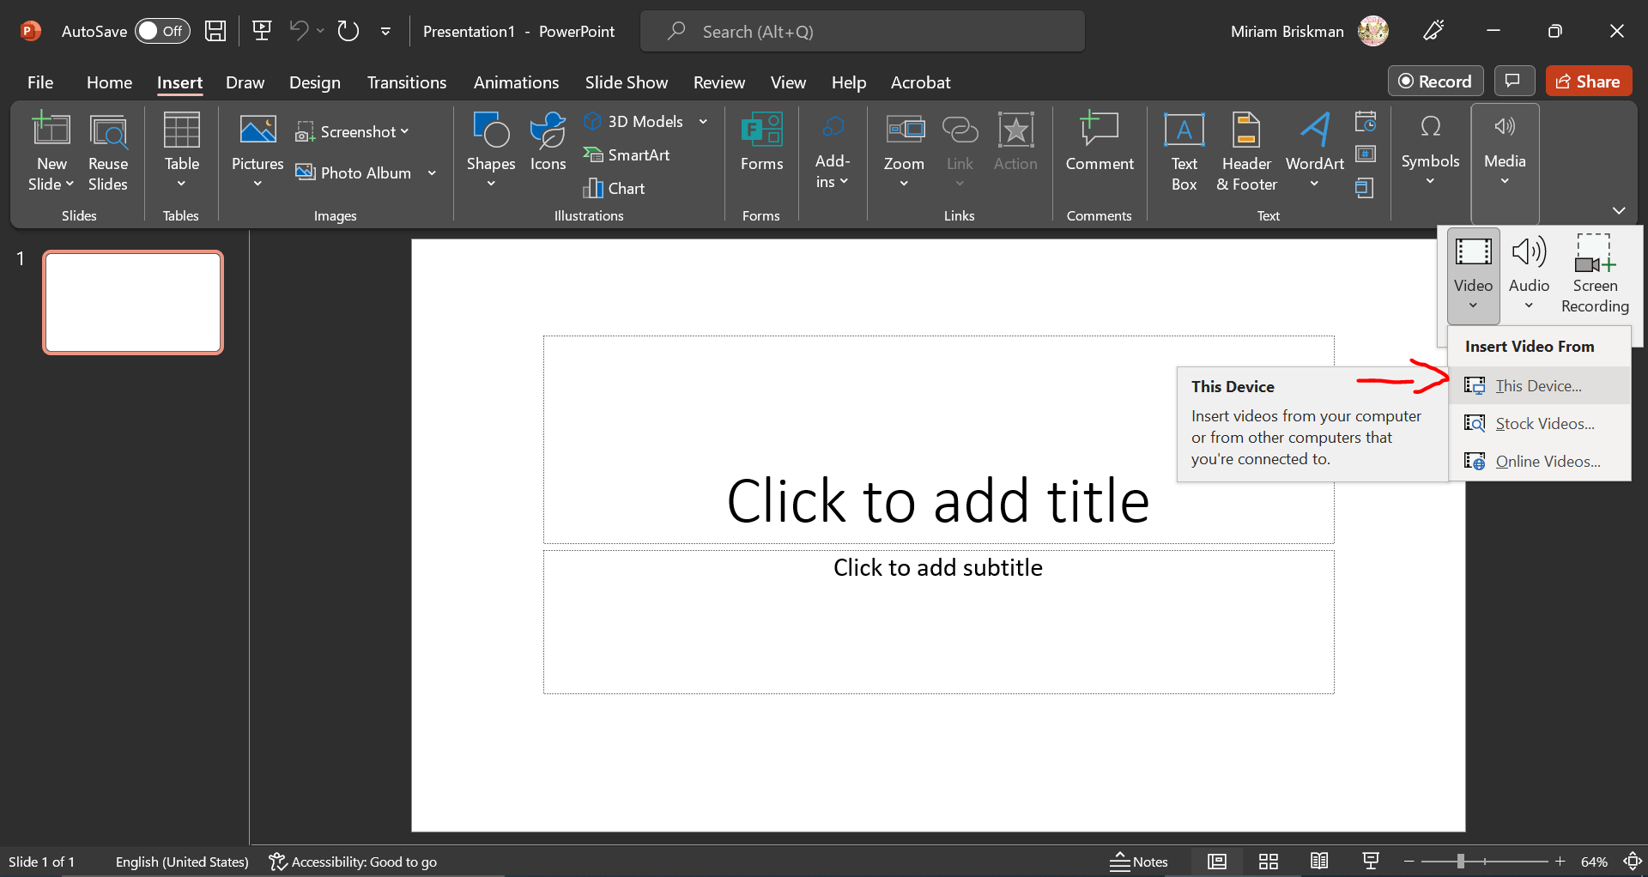
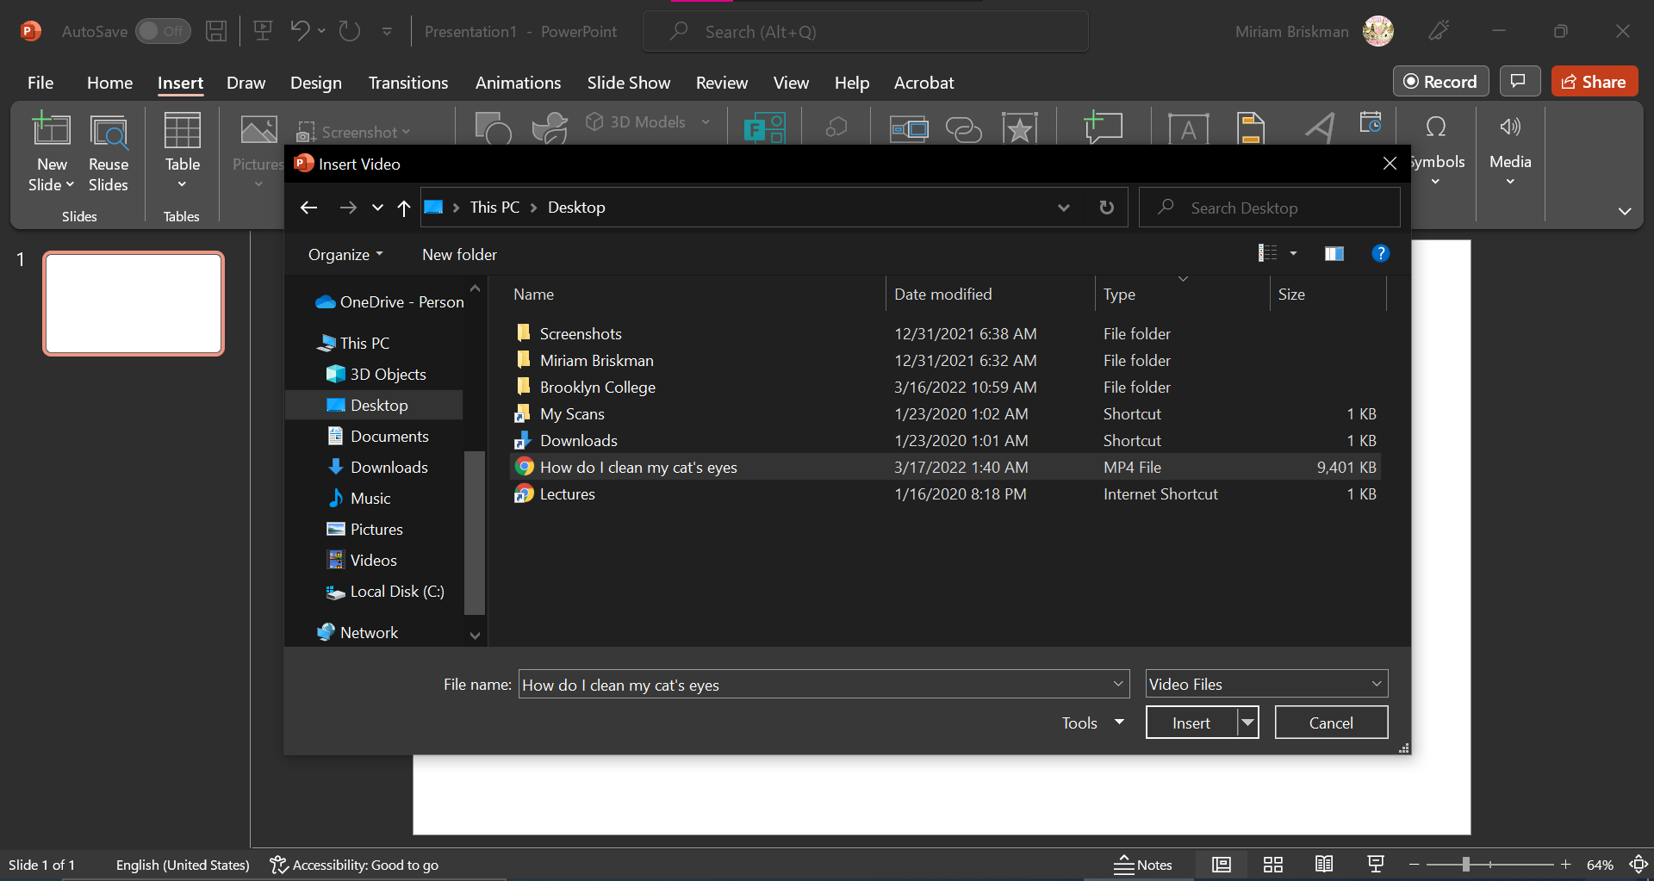
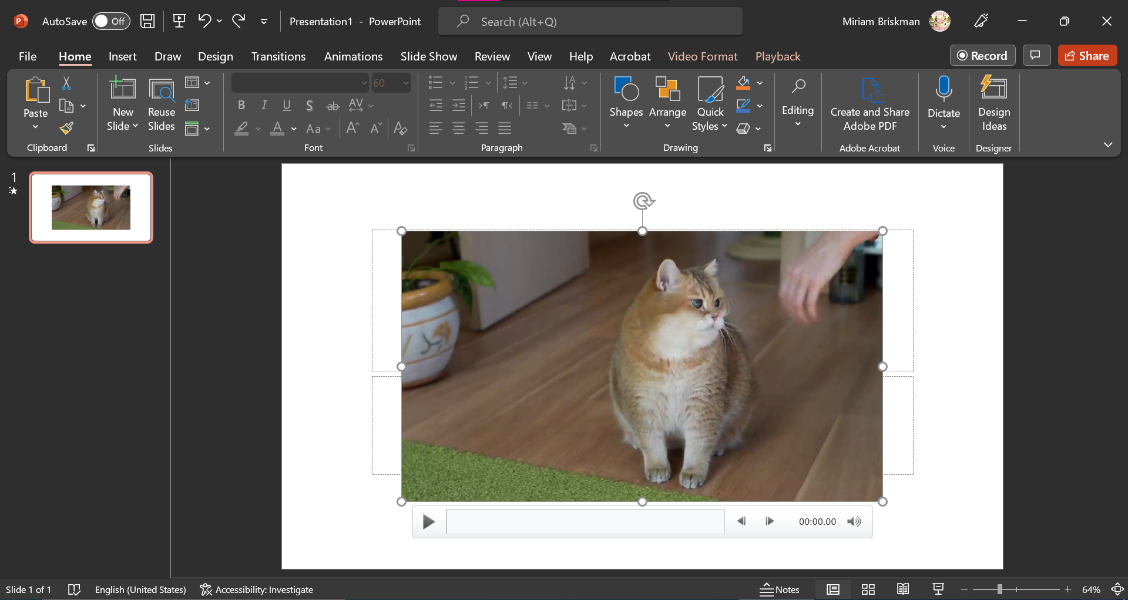
The added video via this option will also feature controls, which are buttons below the video player that let you control the sound, speed, or playing of the video:

Video Tools: Format Tab
In either type of inserted video, you can use the Video Tools: Format tab to change some stylistic features of the video player, including the color of the video, style of the frame, shape of the video’s player, border, alignment of the video on the slide, and the size of the player:
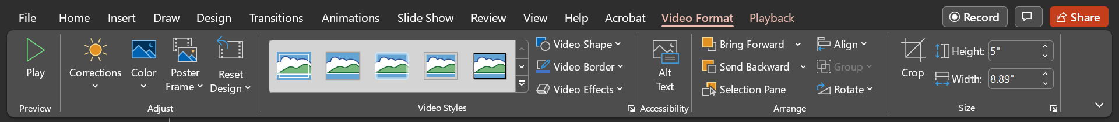
Most of the features on this Format tab are like those you’ll find on the Format tab for Pictures.
In the image on the next page, we changed the style of the above cat video to oval, added a red border, and changed the color to pink.

Resizing a Video
Just as with pictures, text boxes, and other objects, you can resize a video by either of:
- Dragging the sizing handles at the corner of the player,
- Changing the height and width of the video on the Format tab Size group.
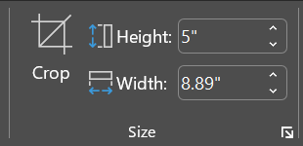
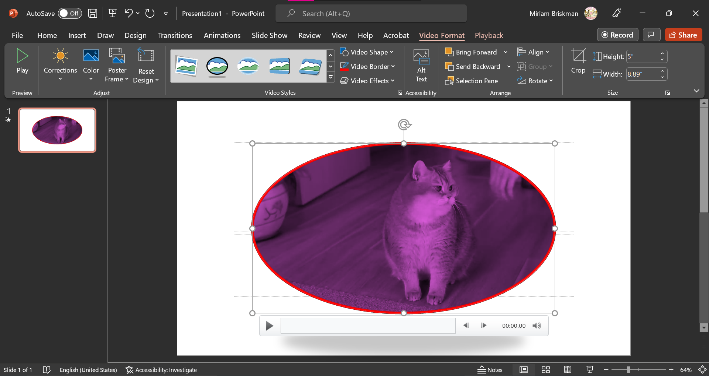

Video Tools: Playback Tab
The 2nd contextual tab that appears when you select a video is the Playback tab. It allows you:
- Select when to play the video during a Slide Show: once you click to play the video or automatically when the slide with the video opens.
- Change the volume of the video (Low, Medium, High, or Mute.)
- Let the video fade for as many seconds as wanted at the start and end of the video.
- Trim (crop) the video’s duration.
- Loop the video until the presenter presses the pause button.
- Add closed captions to the video.
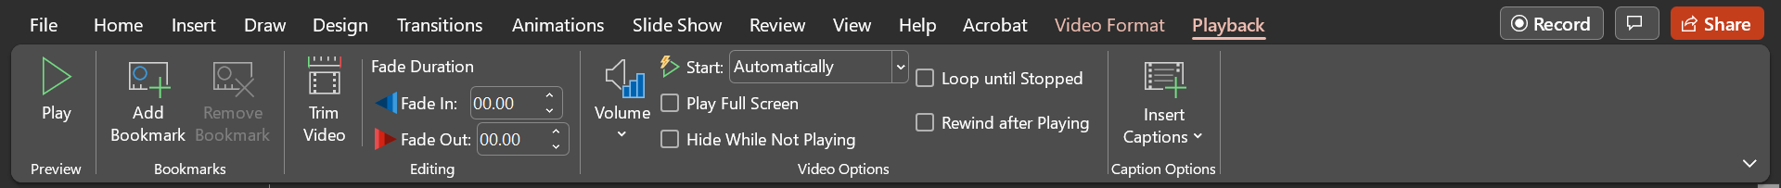
Note that if you link an online video, only option #1 from the list above will be available:
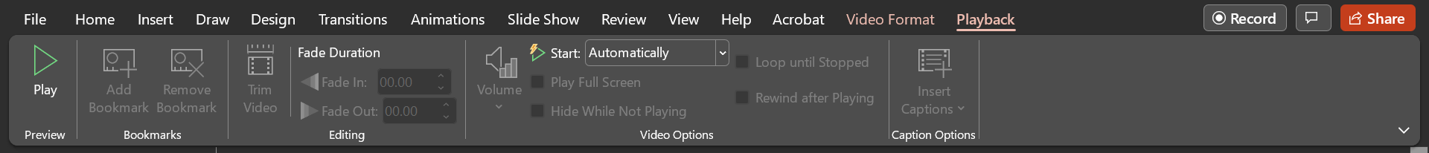
In both cases, you can preview the video (= play the video without opening the presentation as a Slide Show) by clicking on the Play button in the Preview group.

Lists
Just as in Word, you can add bulleted and enumerated lists into the PowerPoint presentation with the use of either of the Bullets or Numbering buttons on the Home tab.
What’s new in PowerPoint is that you can use the Content Placeholder to create bulleted lists inside the placeholder.
Simply click next to “Click to add text” phrase and start typing. Each time you click ENTER/RETURN, you will add a new bullet point below the current point.
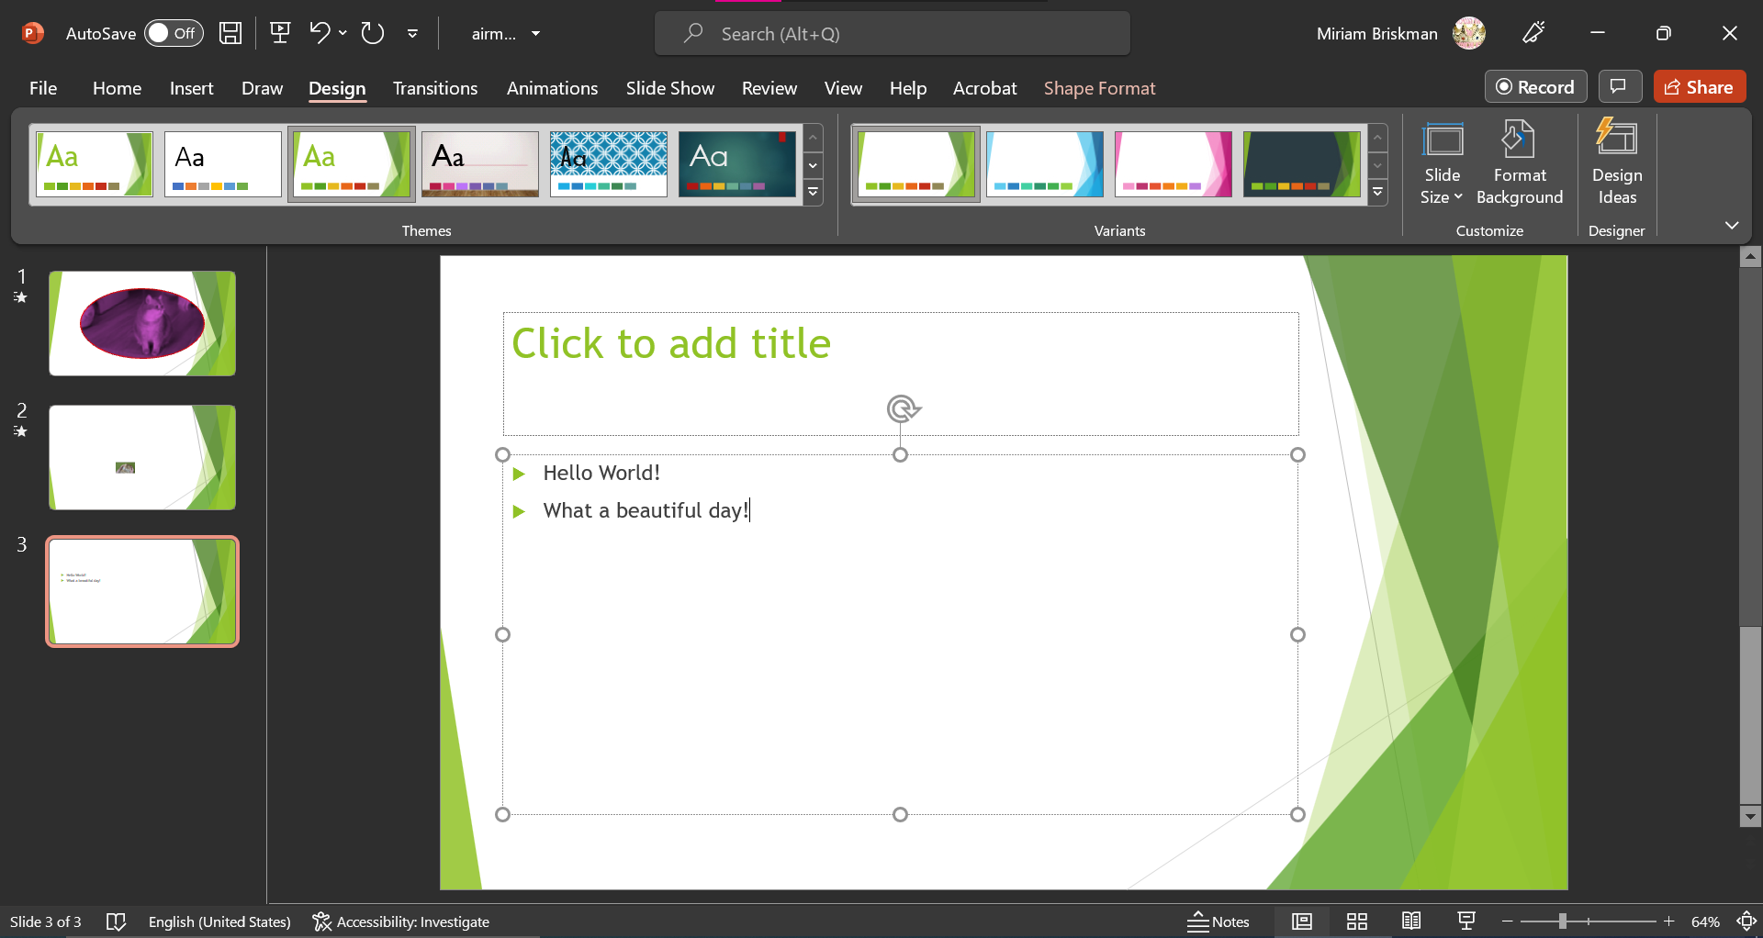
Several more style and structure changes can be made to a list.

Line spacing changes
You can increase or reduce the space between the bulleted or enumerated points. To change it, select the list items whose spacing you wish to change, click the Home tab Paragraph group Line Spacing button , and select the new line spacing.

Multi-level List
A list can have lists within it – sub-lists!
Initially, all the items in a simple list are of Level 1.
To change the level of an item to Level 2, Level 3, etc., click inside the list items and then click on the Home tab Paragraph group Increase List Level button . (See picture on the next page.)
Alternatively, to reduce the level of an item, click the Decrease List Level button  next to it instead.
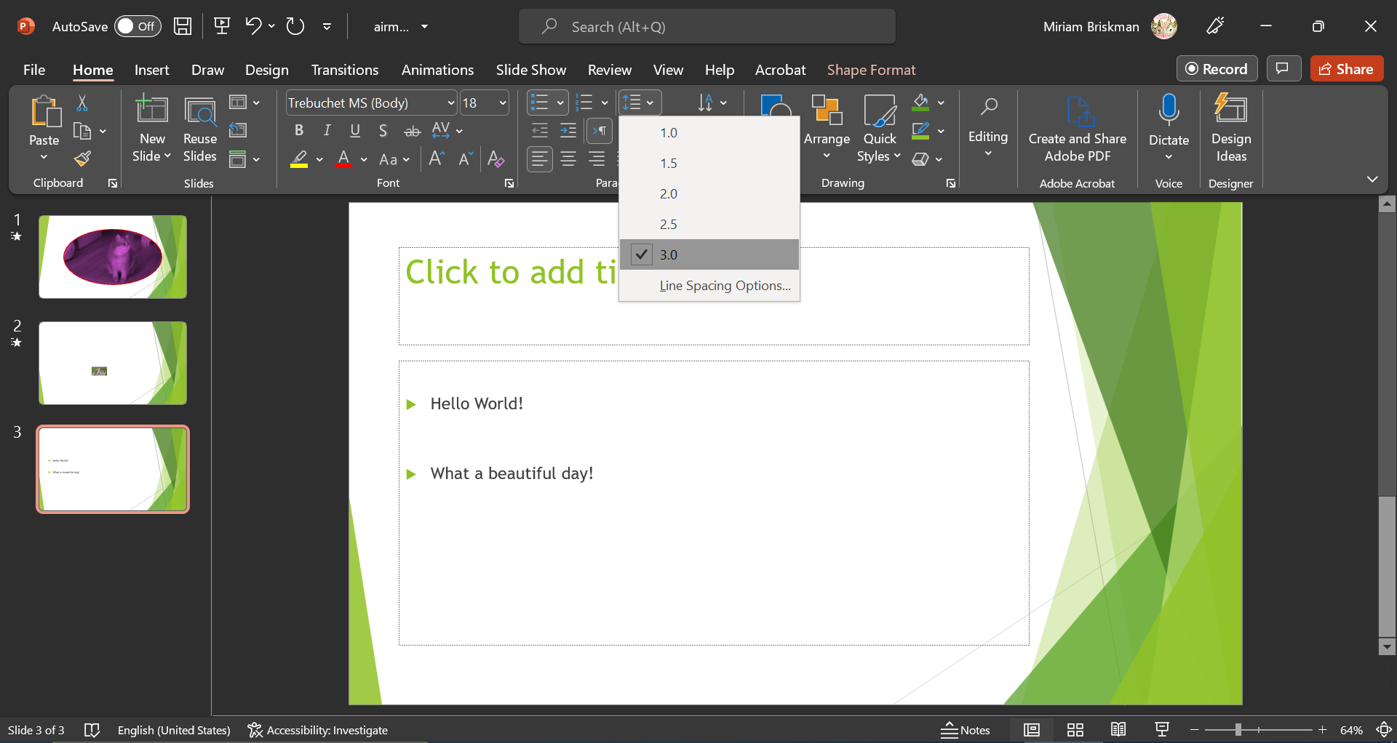
^ Changing the line spacing of the list items to 3.0.
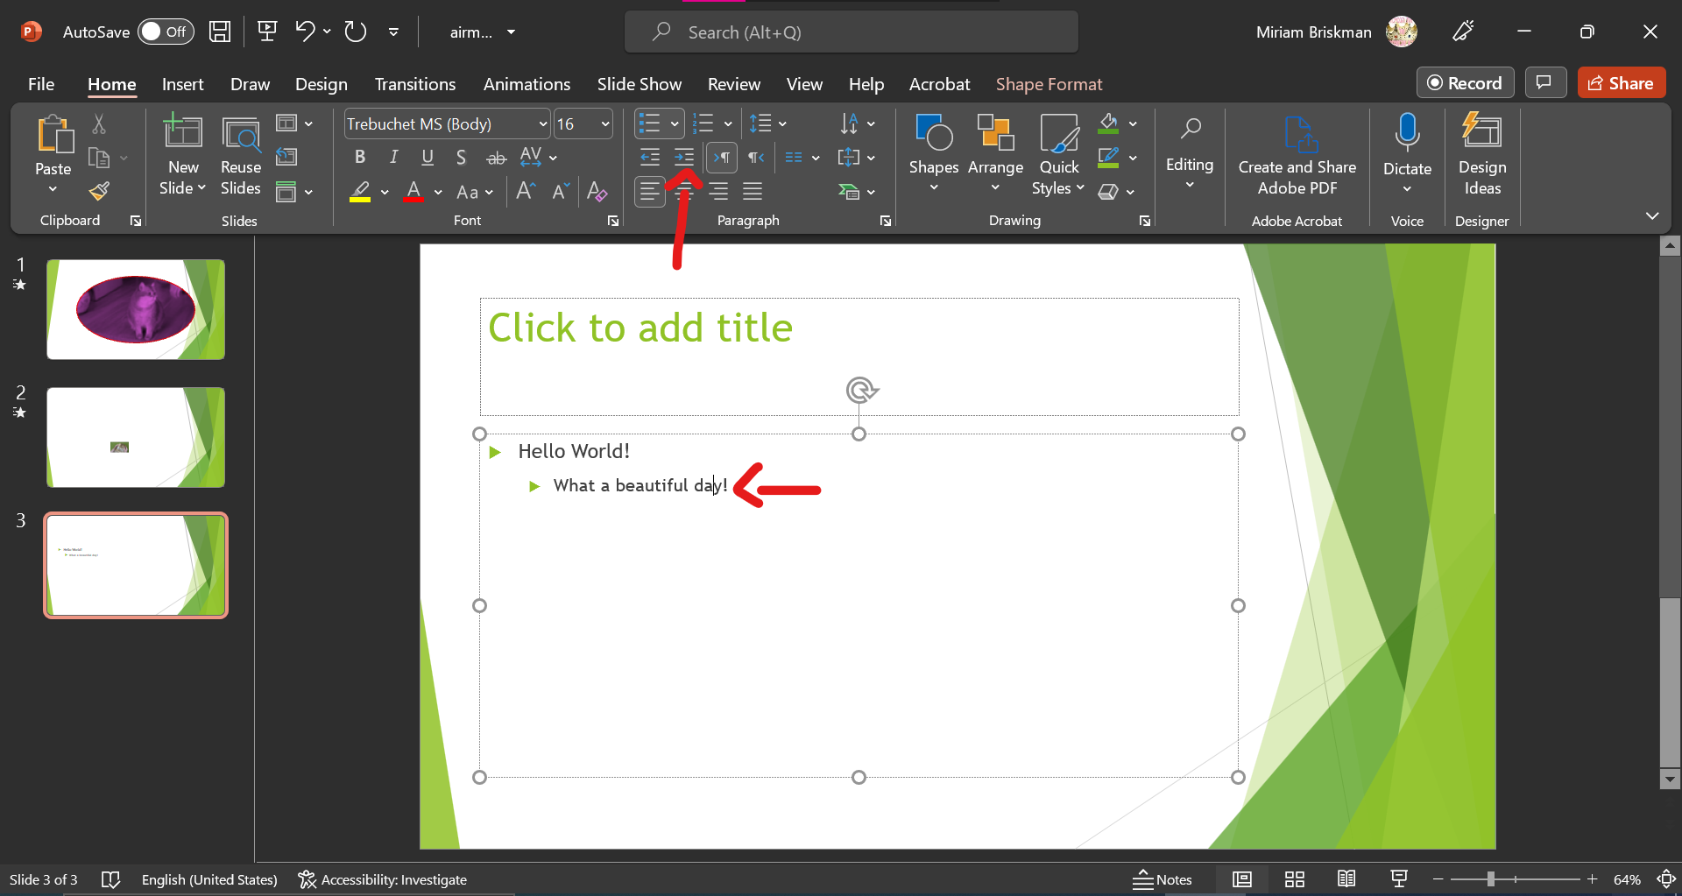
^ Increasing the level of the 2nd bullet point to Level 2.

Changing an Item’s/List’s Style
You can also change the style of the bullet point or numbering.
First, select the full list or the items whose bullet points you wish to change and then click on the arrow next to either the Bullets or Numbering button. The following galleries will show up:
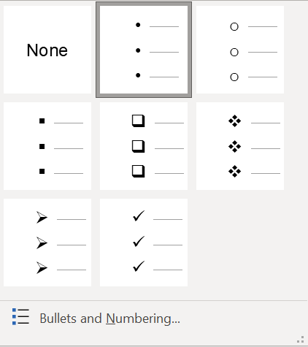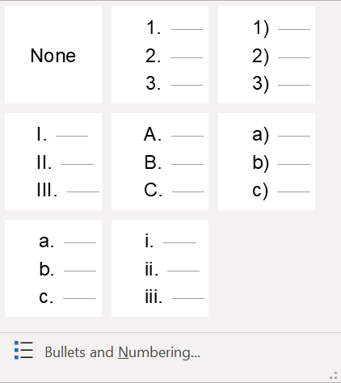
If none of the above styles is adequate, you may choose to make changes through the Bullets and Numbering dialog box, as described in the section below.

Bullets and Numbering dialog box
If you click on the “Bullets and Numbering…” option inside either of the galleries show above, you will be able to add additional features to the selected list items.
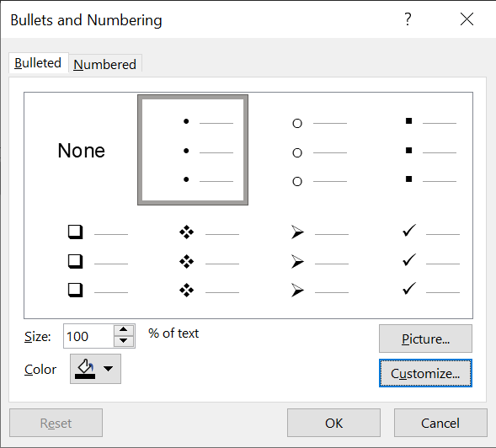
You could change the bullet symbol by hitting the Customize… button. You can then select one of hundreds of available symbols in PowerPoint for your list.
Alternatively, a picture or icon of your choice could become the list’s symbol! Just click the Picture… option and select to either add a picture or an icon. This creates a path to infinitely many symbol options!
In the case of a Numbered list, you can select from which number to start counting by entering a positive integer of your choice into the Start at: box.
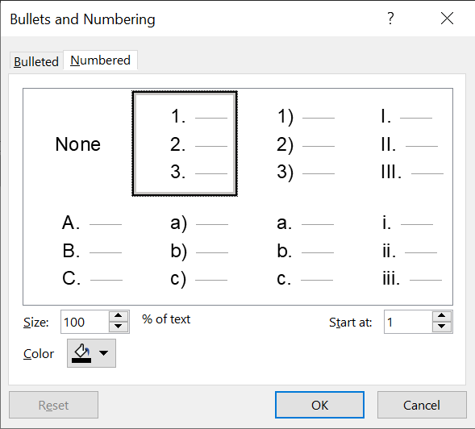
Regardless of whether you use bullets or numbers, you can also change the color of the leading symbol to any one of the 16 million available colors. This Color option, however, is not available when you choose to add a picture or an icon.
Below, we change the bullet points to cats! 
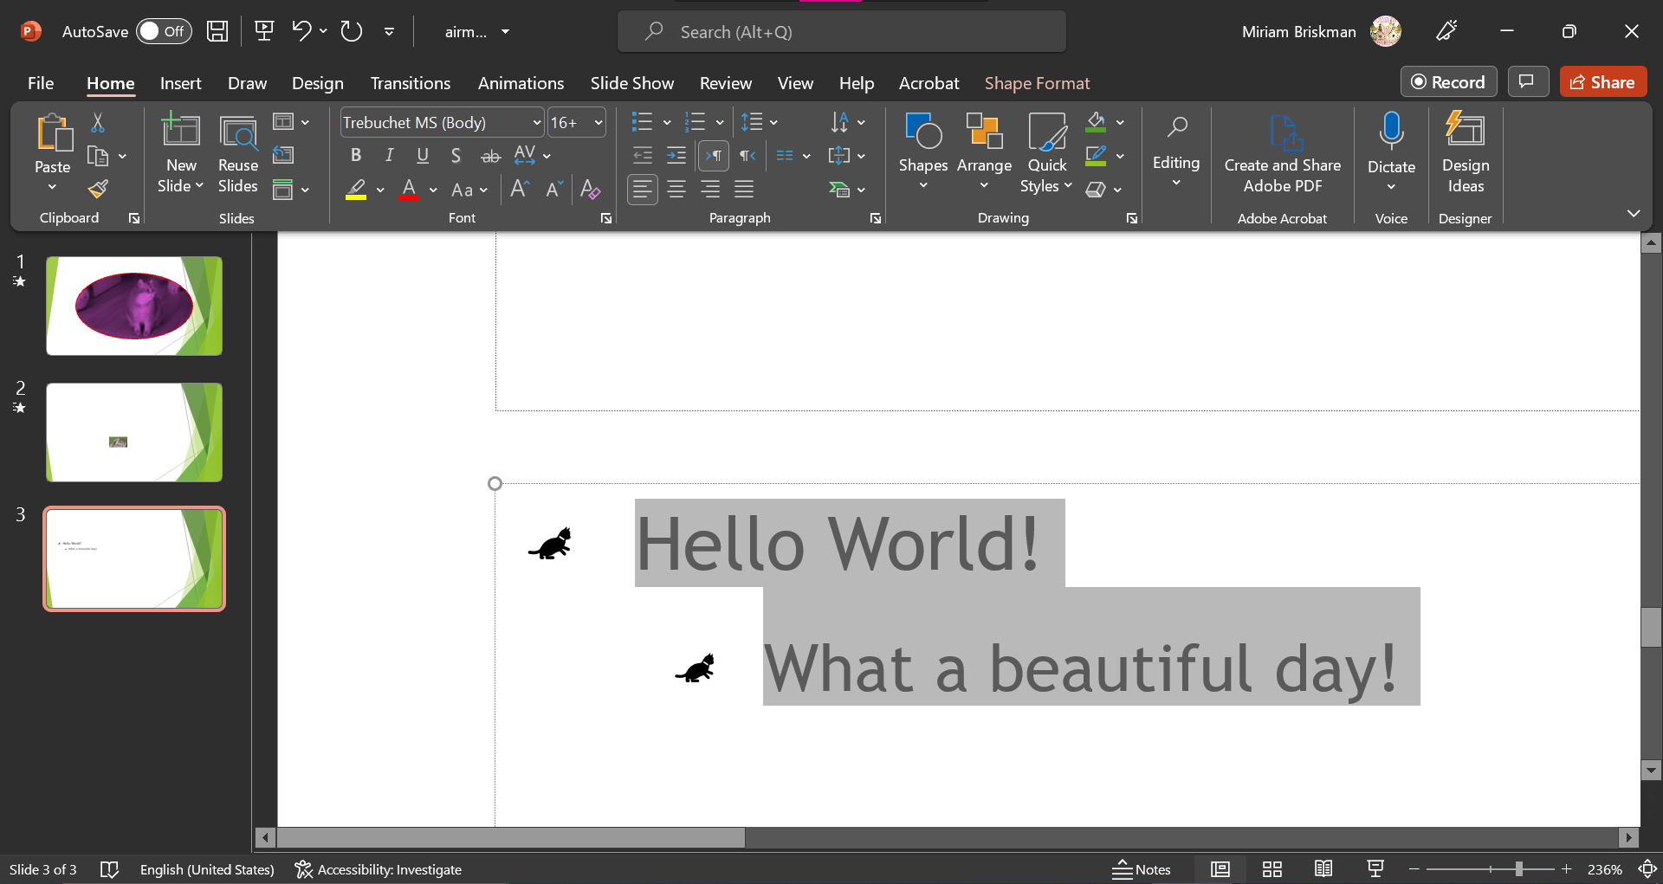
In some cases, though, the size of the icon symbols might be quite small. You could then use the Size: box to change the size of the icons or symbols as needed.
In the image below, we modified the size to 200% of the text’s size.
